**Summary of RADAR**

The term RADAR is an acronym for "Radio Detection and Ranging " which means the detection and measurement of distance by radio waves.

A Radar is a device developed in an army capable of electromagnetic capture and broadcasting that helps detect object within its range. With the radar appearance, the human was able to observe beyond the capability of the human eye. The Radar also allows you to detect through obstructions such as smoke, dust, clouds, rain, foliage and, especially, to create observation abilities in all weather, throughout the day and night.

During World War II, the concept of Radar became familiar and was known as an essential equipment used in the military to enable the participants to detect moving objects or illegal intrusions from the enemies.

Radar is the indispensable device in the current air traffic control, which was invented by Scottish scientist Robert Watson Watt about 100 years ago.

The Radar is a type of positioning vehicle based on the reflections of the electromagnetic waves of interference from interference on the transmission line.

Along with the development of science and engineering, the radar has been continuously improved and developed to serve not only the military, but also for civilian purposes. Today, with its advantages, the radar still acts as a professional supervisor used on marine vessels, planes, ... Or used in the weather forecast, check the speed of the vehicles, ... From there go deep into serving human life. Looking back at the stage of the radar and development history will give us a more pronounced view of this device

**History of Radar development**

The historical phases of the radar were from early discoveries of the electromagnetic field theory to a wide range of practical radar trials extending from the 19th century until the early 20th century before it was heavily researched and developed during and after the Second World War.

In 1842, Christian Andreas Doppler announced his discovery of sound waves. He noticed that when a transmitter moved near a stationary receiver, the receiver obtained a sound signal with higher frequency than the frequency of the transmitter and vice versa when the sound transmitter moved away from the stationary recording power, the receiver obtained the sound signal has a lower frequency than the frequency of the transmitter. The phenomenon is also proven true to electromagnetic waves and also known as the Doppler effect. [1]

In 1864, the equation on electromagnetic theory was given by James Clark Maxwell, also known as Maxwell's equation. [2]

In 1886, Maxwell's theories were carried out in fact and were proven by Heinrich Hertz to demonstrate the above theories with both electromagnetic waves and light waves. [3]

In 1888, Heinrich Hertz proved that radio waves could be reflected when encountering metallic objects or dielectric materials. [3]

In 1900, the inventor Nikola Tesla made the idea of radar-like devices. [4]

Tests for detecting objects with radio wave were first made in 1904 by the German inventor Christian H ̈ulsmeyer. He demonstrated the ability to detect a ship in dense fog conditions but was unable to determine the distance from the generator. He was patented for this invention in January 4/1904 and the invention was subsequently improved by H ̈ulsmeyer with the ability to approximate the distance to the ship. [5]

In 1922, Guglielmo Marconi proved to be able to detect sea vessels and communications through the continental radio waves [6]. At the same time, Albert Hoyt Taylor and Leo C. Young used CW (Continuous Wave) Radar to spot a wooden ship on the sea. [7]

Throughout the years 1920 to 1930, the US, Germany, France, the Soviet Union and especially Britain were focusing on radar research and the technology was considered a military secret. However, despite having spent a lot of time researching, the best radar systems can now only provide information on the direction of large objects appearing in a close distance. The distance and altitude parameters compared to the sea surface are not yet able to be calculated.

Robert Watson Watt-a scientific consultant in the field of communication was invited to the British War Board (BWC-British War Council) to assess about a beam of death (death ray – theoretically a particle or an electromagnetic weapon). Here he invented a complete radar device, used in military and on 26/2/1935, his invention was patented. [8]

Shortly after its inception, the radar was promoted to its strategic effect in the British air Battle of 1940. Although it was only 10 miles (16 km) away, the system was sufficiently large enough to detect that a bomber or fighter was up close. More importantly, the system was used to instruct British fighters against the Luftwaffe directly from the ground while German planes had to search for air targets.

The actual breakthrough only appears when a modern identification radar system is created thanks to the invention of the extremely short (micro) wave used in the home or precisely from the device that generates the microwave-magnetron. Magnetron was invented by John Randall and Harry Boot in 1940 at the University of Birmingham [9], although the radar's range is not yet large, just over 80 km.

The Radar today has evolved in a variety of waves, such as sound waves, radio waves, optics and lazer. In addition to giant radars, super mini radars were also pre-built for super-small reconnaissance aircraft. Each system is tailored to different missions. In addition, technological advancements can change the way a radar system works.

Along with the strong development of the science and Technology of electronic engineering, information technologies, mechanical-electronic industry, new materials, automation, nanotechnology... Today's Radar has also been newly developed and developed in diverse range of waves. The Radar is also designed and deployed both in civil applications.

**Basic knowledge of RADAR**

The Radar operates based on radiation and reflexes of electromagnetic waves in space. Electromagnetic waves spread in straight-line space and at an approximate speed equal to the speed of light in a vacuum (3x108 m/s). Specifically, the radar generates an amount of electromagnetic energy from radiation into space and analyzes the electromagnetic energy from the reflex back from the barrier within its range. Taking a simple example, when we stood in a cave we could hear our voice reflected from the wall, or the bat's ability to detect its path by analyzing the ultrasonic.

A simple radar system is illustrated in Figure _____ . The above radar system consists of a transmitter, a receiver and 2 antennas with the ability to radiated electromagnetic energy on the Transmitter side and to collect the electromagnetic energy from the object in the Receiver. In particular, the system will generate an RF signal (Radio Frequency) on the side of the transmitter and radiation to the space thanks to the antenna in the transmitter side. The signal on when encountering the barrier will be reflected in many different directions which will have the signal reflected back towards the receiver antenna. From there, the antenna on the receiver side will receive a reflex signal and then switch to the receiver, the receiver analyzes the difference between the transmitting signal and the receiver to give information about the distance, velocity, movement direction of the object, ...

An improvement to the radar system above it is instead of using 2 antennas (1 for the transmitter side and 1 for the receiver side) the radar system in Figure ____ using only 1 antenna for the receiver and play. However, with this system, due to the use of only 1 antenna, it is necessary to isolate the transmitting signal and the receiving signal by the duplexer, thereby reducing the bulky system of the systems compared to the 2 antennas above. Duplexer also helps to protect the receiver from large power signals from the transmitter. In the next section, we will explore more detail about the components that make up a radar system.

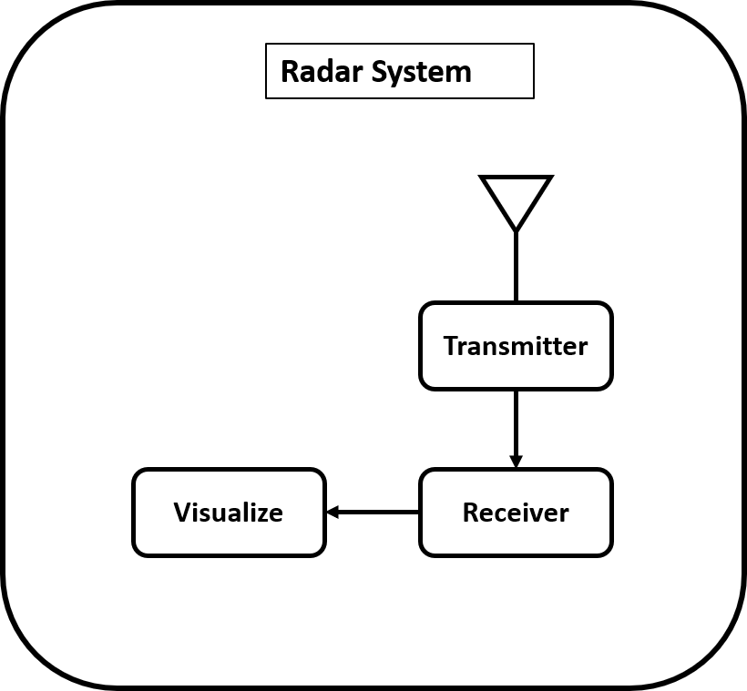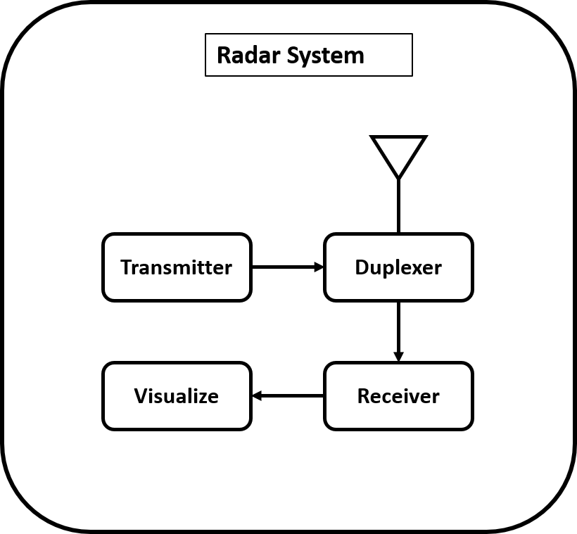

**2.2 Components of a simple RADAR System**

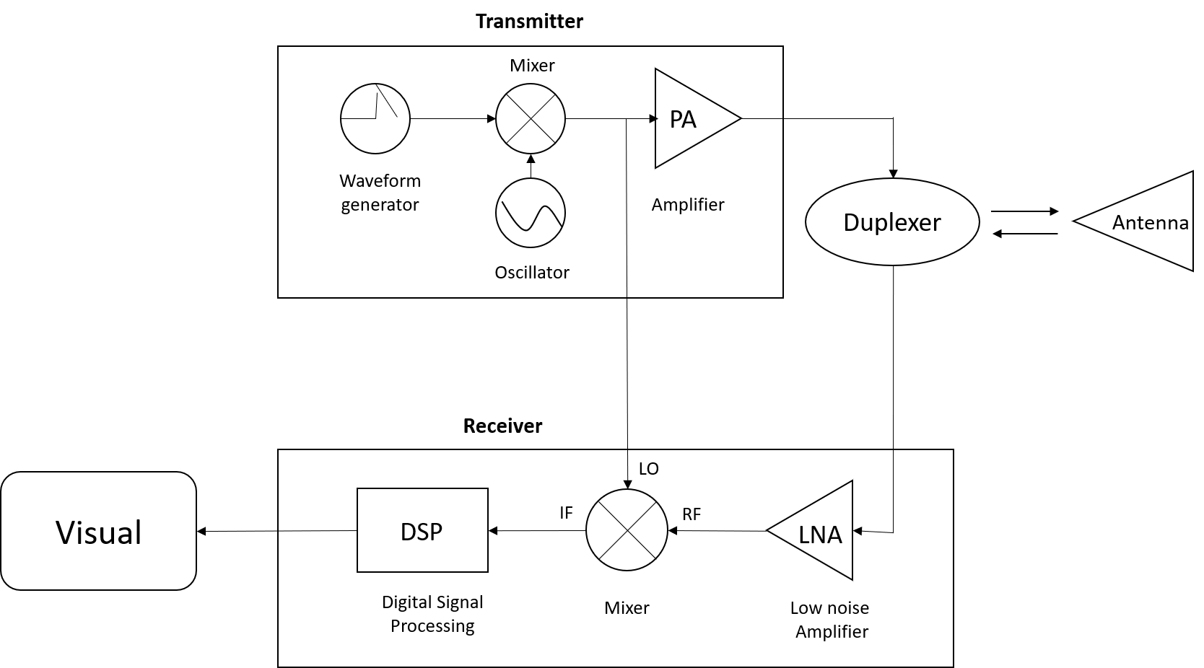

**2.2.1 Antenna**

In the radar system, the antenna acts as the interactive unit between the system itself and all types of electromagnetic waves that are present in space. Thus, the antenna acts as a transmission unit, spreading and the direction of electrical energy radiators from the space as well as receiving the electromagnetic wave from the feedback from the object.

In the antenna design, there are many parameters that are of interest such as: radiation pattern, the density of radiation power (W), the radiation intensity (U), Beamwidth (Half Power Beamwidth-HPBW, First Null Beamwidth-FNBW), orientation (D), Gain, Antenna Efficiency, bandwidth and finally Polarization. However, in order to quickly assess an antenna, it is usually based on two parameters that are the gain and radiation graphs. Looking at the figure ____ We see that the gain of an antenna is understood to be the difference in the radiation intensity of the antenna itself compared to the isotropic antenna. There are two types of antennas commonly used in radar systems which are horn antennas and pan parabolic dish antenna will be mentioned in the next section.

**2.2.1.1 Horn Antenna**

Antenna speakers used to be used for transmitting and receiving RF signals or being used as feeder in parabolic antenna.

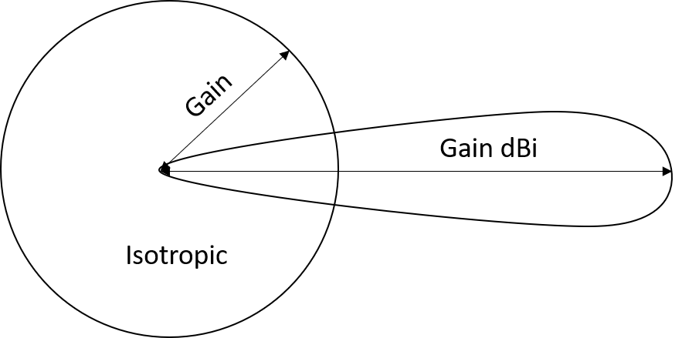

The typical shape of a loudspeaker antenna is a flare-oriented surface that is like a speaker (horn) that allows radiation waves from the antenna to the free space in a defined direction.

There are 4 kind of horn antenna which is describe in figure ____

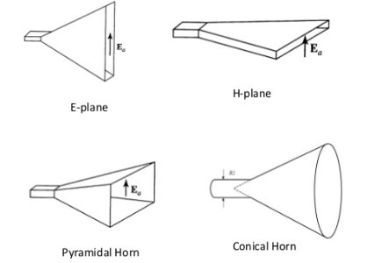

With a simple structure, Horn antenna is usually used at UHF frequencies (300MHz-3GHz) or even higher. Horn antenna also has huge bandwidth so it improving the eficency of the antenna in different frequency ranges.

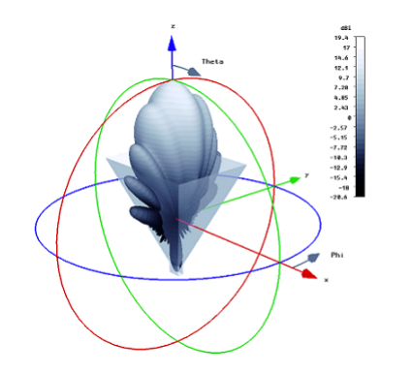

Figure : 3D graph of horn antenna

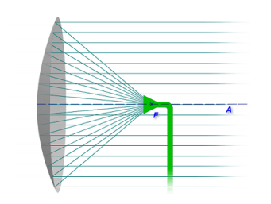

Figure

**2.2.1.2 Parabolic dish antenna**

Figure ___ Describes a common parabolic antenna in practice with a structure consisting of a parabolic reflex surface (reflector)-also known as a parabolic dish and an electromagnetic broadcast called a feeder (usually a dipole antenna). The material that makes the reflector is usually a metal mesh plate with the size of those holes must be less than λ/10. The main mesh plate creates a reflective surface for the electromagnetic wave. Since then, the enhancement is the orientation and gain of the antenna. Usually, with the same power output, parabolic antennas can give the greatest gain and with the narrowest wave. To create a narrow wave, the reflector surface must be much larger than the wavelength length so that the parabolic dish antenna is often used for high frequency ranges (UHF or SHF).

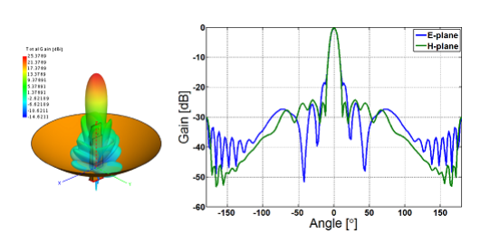

Figure : Radiation of parabolic dish antenna

**2.2.2 Duplexer**

As we mentioned above, Duplexer is used in the case of only one antenna for both collecting and transmitting the signal. There are two requirements about duplexer needs to satisfy:

**Firstly**: isolate the receiver from large power signals at the transmitter to avoid jamming parts on the receiver side.

**Secondly**: ensure the transmission and receiving process occurs continuously on the same antenna. In fact, the duplexer is commonly used as Circulator, a 3-door network system described in Figure 2.9 and with the S matrix as follows:

$$S=\left[\begin{matrix}0 & 1 & 0 \\ 0 & 0 & 1 \\ 1 & 0 & 0\end{matrix}\right]$$

Assuming we connect the antenna to the port 2 of the circulator, signals from the transmitter that's been connected into the gate 1 and the receiver will be connect to gate 3 of the circulator. Ideally, looking at the S matrix we see that when the signal from the gate 1 will be pushed into antenna radiate to space and there is no signal at the gate 3. Same thing, if a signal in the port 2, that signal will be moved to the gate 3 of circulator simultaneously isolate with the portal 1. However, in the reality of the signal will not be completely isolated, but still exists loss about 0.1 - 0.5 dB.

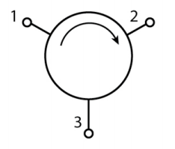

**2.2.3 Mixer**

Mixer which used to convert input frequency into a signal that has the same form as the original signal but at another frequency, may be higher or lower than the original frequency.

Usually, it is common to transfer signals from the intermediate-frequency (IF) to high frequency (RF) and vice versa depending on the purpose of the designer and the use of the system.

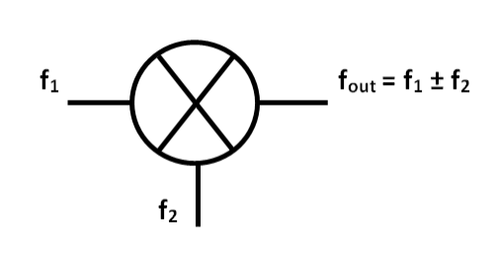

Figure : Diagram of the Mixer

As we can see that, the mixer will receive signals at two port f1 and f2 then the output will combine these signal.



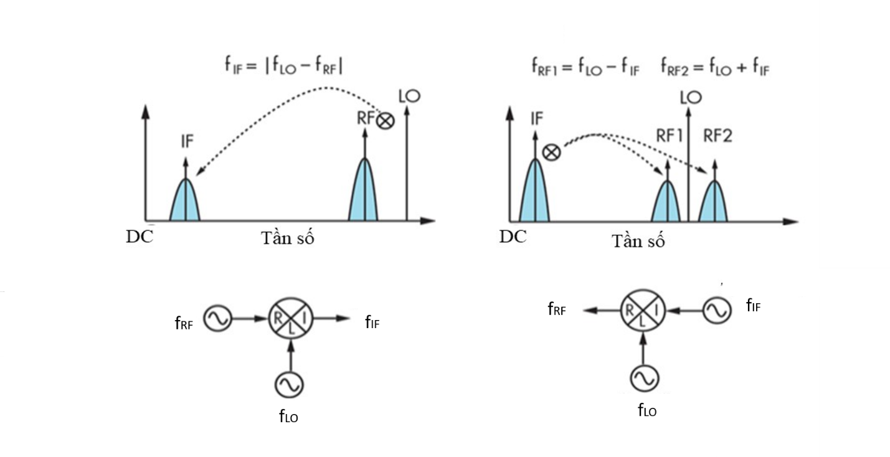

The changing of the frequency must be through a signal from the oscillator with f­­LO frequency. As a result, the signal from the oscillator is allowed to be the input signal of the mixer, while the RF and IF ports can switch roles for each other as the second input of mixer or output of the mixer. For lowing frequency, the second input signal is the RF signal, and the signal at the output will be IF signal which have $f_{IF}=\left|f_{LO}-f_{RF}\right|$. On the contrary, for the frequency transfer, the second input signal is the IF signal, and the output signal will be the RF signal, which have $f_{RF1}= f_{LO}-f_{1F}$ and $f_{RF2}= f_{LO}+f_{1F}$

In practice it is common to use a frequency mixer combined with a filter to selectively choose the desired frequency in the intermediate frequency or high frequency. As we know, the signal at the frequency mixer output exists at two frequencies. Therefore, for the transfer of the frequency, in order to derive the intermediate-frequency signal we must use a low pass filter (LPF) to remove the unwanted signal

**2.2.4 Oscillator**

Oscillating and synthesize frequencies are crucial in the field of radio communication. Oscillators transform the DC electric energy into an AC signal used as a wave bearing directly or through the mixer to change the frequency of signals from the IF to RF or vice versa. There are many types of oscillating circuits such as:

* LC oscillating circuit: Clapp, Colpitt, Hartley, Pierce, …
* VCO and VCXO

In particular, VCO and VCXO is used in many applications because it can change the frequency depending on the DC voltage value set o varicap (VTune) of the VCO or VCXO circuit.

**2.2.5 Power Amplifier**

The power amplifier is usually used to raise the RF signal power from a low to a higher level depending on the gain of the amplifier. In the radar system, the power amplifier is used on the transmitter to raise the power level for the transmitting signal thereby enhancing the range of radar. The power amplifier must satisfy the requirements such as high performance, high frequency selectivity.

**2.2.6 Low Noise Amplifier**

Noise is an unwanted signal, appearing from various sources inserted into signal reduces the signal quality of the receiver leading to information discrepancies. The quality of the receiving signal is rated by the SNR coefficient (signal-to-noise ratio) which is the correlation of the signal strength versus interference. The signal level obtained from the antenna is usually very small and has included interference from the transmission environment, if that signal is amplified in a high noise environment will result in reducing the amount of information we receive, sometimes misleading or lost information.

Low noise amplifiers are used to raise the signal level with least the amount of interference that is added to the signal depending on the design quality. In the radar, the low-noise amplifier is used as an amplification for the signal on the transmitter as well as the amplifier for the signal at the receiver. For low-noise amplifiers, the parameter is concerned that the "Input Noise Figure " which is the amount of noise added to the signal after amplification. The ideal amplifier will have the coefficient INF = 0 dB, however in fact never achieved so, usually the < 3dB INF factor is consider as good and if INF < 1.2 dB is considered very good.

­

**2.2.7 Transmitter**

Transmitter model is illustrated in Figure __. In particular, detection system includes a Waveform Generator combined with the Mixer and Oscillator give the desired frequency then this signal is amplified by the power amplifier (PA) and transmitted to the antenna for radiate to free space.

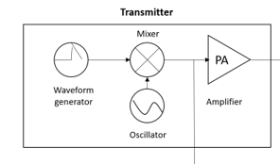

Figure : Transmitter model

The antenna size is depended on the signal wavelength, raising the frequency will minimize the size of the antenna especially for radar that have transceiver antenna. In addition, high frequency will help us to take full advantage of the electromagnetic spectrum. However, the transmission of high-frequency signals resulted in the level of loss of the signal during the propagation process, thus depending on the purpose and requirements of each system that we choose the appropriate frequency.

**2.2.8 Receiver**

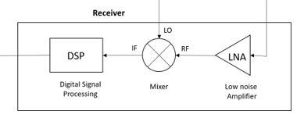

Figure : Receiver model

Figure ____ illustrates a basic radar signal receiver model. Similar to the transmitter, the receiver also uses an amplifier to amplify the signal. However, the difference is that before crossing the amplifier, the signal must pass through the limiter to limit the large power signals that can cause the destruction of the receiver components. In particular, the signal is passed through the filter to enhance the signal selectivity then brought through the low-interference amplifier-was said above-to limit the maximum level of interference power to the signal after being amplified. The signal after the amplifier is mixed with the signal on the transmitter through the mixer to obtain the difference information between the receiving signal and the transmitting signal. The signal carries the information transferred into the signal processor to analyses and return the results depending on the purpose of the radar. Usually, pre-processing signals are given through a low-pass filter inside the signal processor to select the signal again to restrict the information handling of unnecessary signals and avoid spectrum overlap.

**2.3 Radar equation**

**2.3.1 Friss equation**

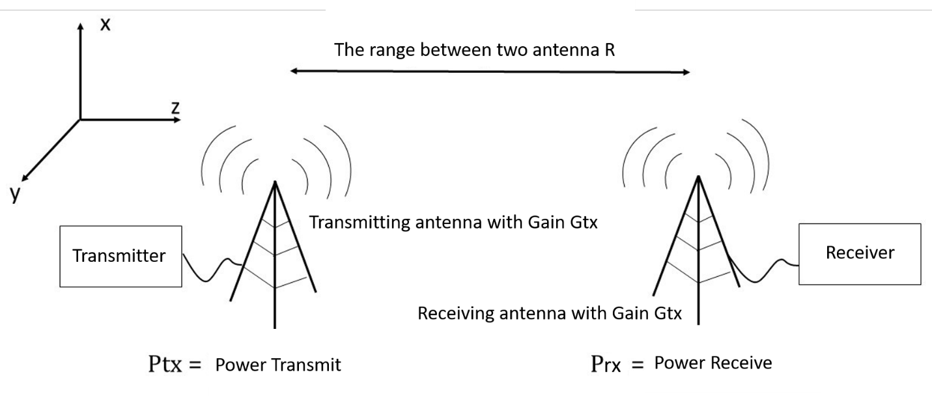

**Figure :** model transmitting signal in free space

The Friss equation is used to estimate the power that is transmitted from the antenna to the receiver through the free space with given power level Pt. In particular, the Friss equation is used in designing satellite communication and VIBA communication.



Pt ­­: Power of Transmitter

Pr: Power of Receiver

Gt: Gain of transmitter

Gr: Gain of receiver

R: The distance between two antennas

**2.3.2 Radar Cross Section - RCS**

The RCS parameter also calls the reflection area of the object-is a parameter that is considered at the remote school of the transmitting signal (far-field), which is the characteristic of the electromagnetic wave scattering of the object and is defined as the surface on which the wave reflexes back The antenna collects when the waves reach the object and scattering in different directions.

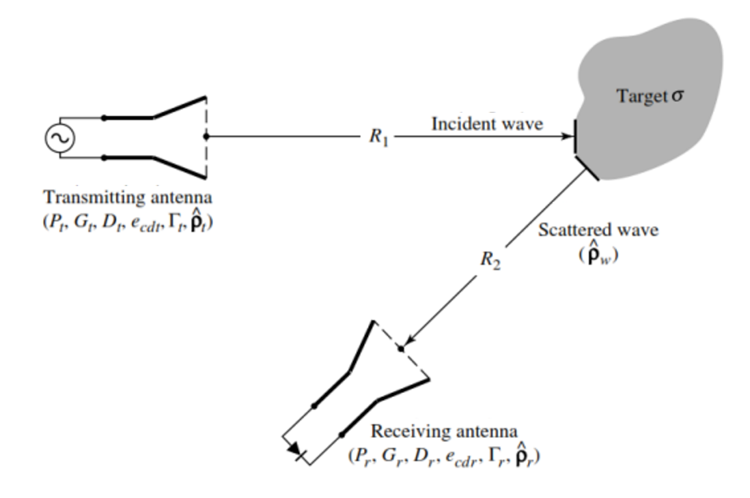

Figure : Scattering characteristics of objects in transmitting and receiving radar waves

**2.3.3 Radar Equation**

Figure ___ depicting a typical radar wave model, in which, electromagnetic waves are radiated to space with the power as Pt to the flying object in this case a plane and a portion of the electromagnetic wave reflex the antenna to the receiver is Pr. Through it we see that, based on the delay time between the receiver signal and the transmitting signal, it is possible to calculate the distance of the aircraft on the radar system. In addition, the determination of the frequency change between the receiver signal and the transmitting signal gives us information on the velocity of the aircraft through the Doppler effect.

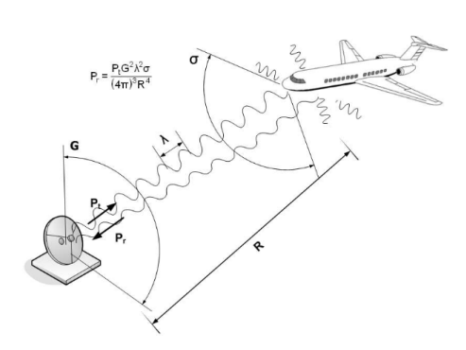

Figure : The simple model of transmitting between radar and object

However, a problem that is how to determine the required power level to be able to obtain the two parameters mentioned above. As we known that reflex waves from free space will be accompanied by interference, so receiving the signal at a sufficient signal and with the SNR coefficient is an issue. To solve this issue, there are an equation for radar propagation:

$$P_{r}=P_{t}+2G+σ_{dBsm}+20\log_{10}{(}λ)-30\log_{10}{(}4π)-40\log_{10}{(}R)$$

$P_{t}$: Power of transmitter [dBm].

G: Gain of antenna [dBi].

$λ$: Wavelength of the transmitter [m].

$σ_{dBsm}$: Radar cross-section (RCS) [dBsm].

R: Distance between antenna to object [m].

**2.3.4 The operate range of radar**

The maximum range of radar is base on the equation ___:



$R_{max}$: The maximum range of the radar [m]

$P_{ave}$: The average power of radar [W]

$G_{tx}$: Gain of the receiving antenna

$ρ_{rx}$: Efficiency of receiving antenna

σ: Radar cross-section (RCS)

$L_{s}$: Loss of the system

α: Attenuation coefficient of spread signal in free space

$F_{n}$: Noise Figure of the system

k: Boltzmann constant (1.38.10−23)

$T_{0}$: Temperature (270oC = 2900K)

$B_{n}$: Bandwidth of the system [Hz]

${(SNR)}_{1}$: Signal to noise ratio

n: The number of pulse

$E_{i}(n)$: The efficiency of transmitting pulse

τ: The range of pulse

$f_{r}$: Repeat frequency [Hz]

The aperture (Arx) and efficiency (ρ) of receiver the antenna is relate with the gain (Grx)

$$G_{rx}=\frac{4πA_{rx}ρ}{{λ^{2}}_{c}}$$

$λc$: The wavelength at the intermediate frequency [m]

Attenuation coefficient (α) normally close to 0 for short-range radar systems, so that $e^{2αR_{max}}$ = 1. The formula is generalized for use radar pulses and radar signals using continuous wave.

With the radar using continuous wave, $P_{ave}=P_{t}$, with $P_{t}$: power output of the system [W].

With the radar using pulse signal: $P_{ave}=P_{t}τf_{r}$

**2.4 Common Radar type**

There are many common types of radar used today, depending on the purpose and use of the operating frequency range or emission signals (continuous wave or pulse) that we divide into different types of radar. In this section we only look at the most overview of some of the popular radar types, including three types of radar that is CW (Continuous Wave) Radar, FMCW (Frequency Modulated Continuous Wave) radar and Synthetic Aperture Radar.

**2.4.1 CW (Continuous wave) radar**

The CW (Continuous Wave) radar system generates the signal at a fixed frequency and is often used to determine the velocity of the object. It works according to the Doppler effect by identifying the frequency difference between receiver and transmitter then give the information about the velocity of the object. However, the radar system was unable to determine the distance from the object to the radar due to the delay time between the receiver and transmitter, which is also the downside of this type radar. Some applications of CW radar that determine the velocity of the transport or motion sensors are often used in commercial centers.

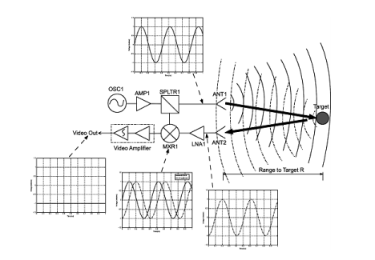

Figure : CW radar model

**2.4.2 FMCW (Frequency modulated continuous wave) radar**

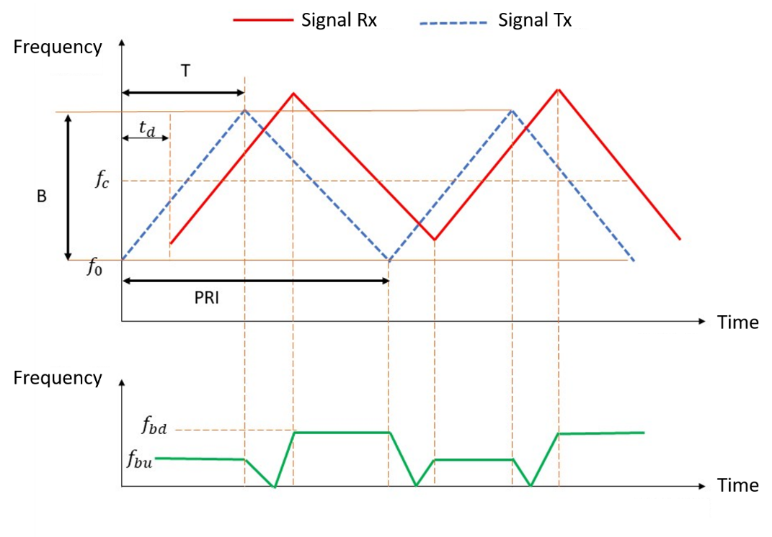

Figure : Modulated wave on FMCW radar

For CW radar system we are unable to determine the distance of the object because the delay time between the signal of transmitter and receiver cannot be determined. However, it is possible to develop the system that able to determine the delay period in measuring the distance of the object by processing the transmitter signal so that the frequency of the signal changes in a cycle. When the feedback signal is received, from the change in frequency we determine the information about the time delay of the signal then we can determine the distance of the object.

Some of this radar's applications are in fact determining the current altitude of an aircraft or a flat survey of a surface. There is also another radar that can determine the distance of the object that is a pulse radar that will be mentioned later.

**2.4.3 Synthetic Aperture Radar**

synthetic aperture radar is considered to be in the mapping radar group. These radars are often used on aircraft or satellites to recreate the image of a surface by scanning it with electromagnetic waves. In this case, the SAR system will move along the surface where it wants to recreated and store the data then transferred to the signal processor to reconstruct the image of the surface. The higher resolution of the system the clearer images we received and it can be compared with photographs from the camera.

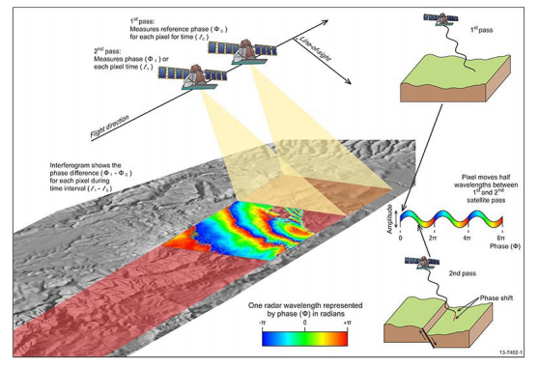

Figure : Model of Synthetic aperture radar

One advantage of this type of radar compared to the camera is that it is possible to function regardless of day and night and is not affected by weather. In addition, in defensive technology an ISAR system (Inverse Synthetic Aperture Radar) is used in the opposite way, in which case the Radar will stand still and reappear the image of moving object when this object moves across the antenna of the System.

The main difference is in either the moving radar or moving object. For the SAR system, the radar will move the subject and the object should be stationary, whereas for the ISAR system the radar will stand still and the object will move. One common point to notice is that both systems use the same principle of operation that is based on the relative movements of the radar and objects from which the object image is recreated.

**2.4.4 Simple pulse radar**

Pulse Radar does not use a continuous carrier wave as 3 radars mentioned above, this radar has signal in the form of pulses in a determined cycle.

With the type of pulse radar there are some parameter that we have to consider:

* Continuous Frequency (CF)
* Pulse width (PW)
* Modulation
* Pulse repetition frequency (PRF), with $PRF=\frac{1}{PRP}$

PRP is Pulse Repeat Period. Where the PRF parameter is the unambiguous parameter of the received information (velocity or distance). Therefor the PRF have to be suitable for radar purposes and requirements.

|  |  |  |
| --- | --- | --- |
| **PRF** | **Unambiguous in distance** | **Unambiguous in Velocity** |
| **PRF low** | YES | NO |
| **PRF intermediate** | NO | NO |
| **PRF high** | NO | YES |

Table : The relation between PRF and pulse radar

The distance of object is determined by the time delay between the received pulse and the previously broadcast pulse. The narrower the pulse width is, the more accurate it is to calculate the delay time between the transmitting and receiving signals and the more precise the information about the object's distance. Therefore, the pulse width of the signal determines the distance resolution of the object. Usually this radar is used in marine surveillance radar systems, which define distances and radar weather.

From the idea of a simple pulse radar, the scientist developed two other types of pulse radar, the Pulse Doppler radar and MTI radar with the ability to determine not only the distance but also the velocity of the object being common applied in practice.

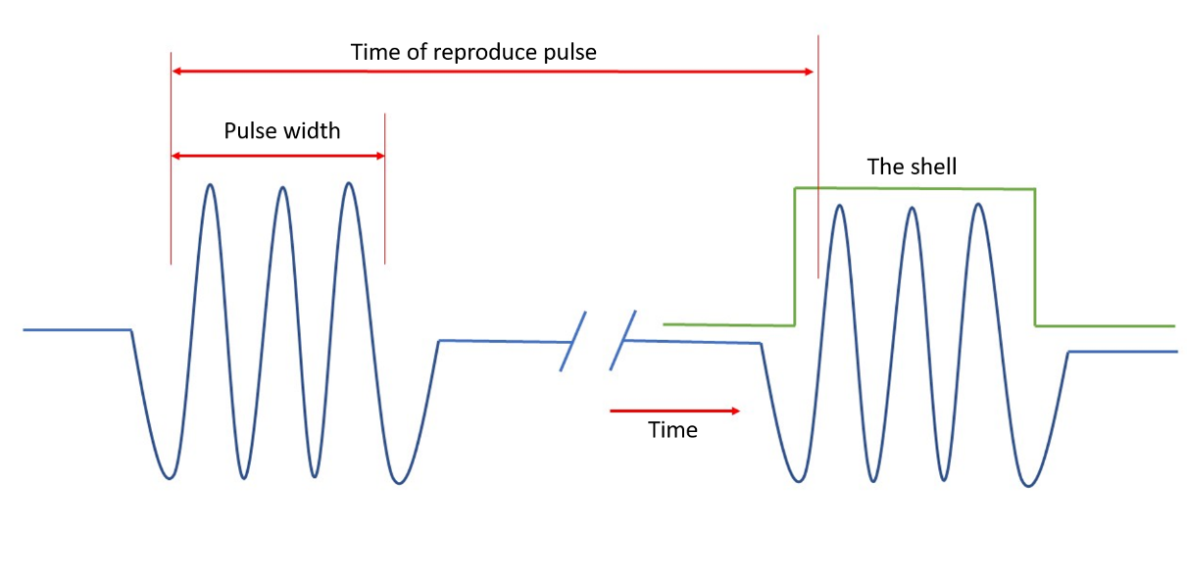

Figure : Pulse that emitted by pulse radar

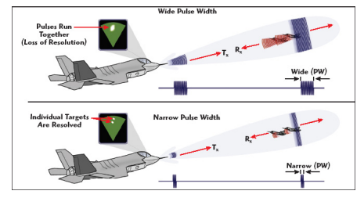

Figure : Model of pulse radar and the resolution of pulse width

**2.4.5 Moving - Target Indication (MTI) Radar**

The idea of developing the MTI radar system is the capable of being able to distinguish moving objects at high velocity such as aircraft or missiles compared to other objects with slow or non-moving speeds such as buildings, Mountain, Clouds, ... As a result, the MTI radar is often used in observation stations of flying objects or in military surveillance and defense systems.

Operating similarly to a radar pulse system, however the system uses a pulse signal with a low PRF coefficient, thereby giving us information about the distance accurately while information on the velocity of the object is quite vague. Therefore, for stationary objects or very slow motion, the signal is less changes in terms of amplitude while for objects with high velocity gives a change in the amplitude of the receiving signal from that helps us to distinguish different objects.

**2.4.6 Pulse Doppler Radar**

Similar to the MTI system, the Doppler radar Pulse system also works based on the Doppler effect to determine the velocity of the object. However, the system works with higher PRF parameters than the MTI system.

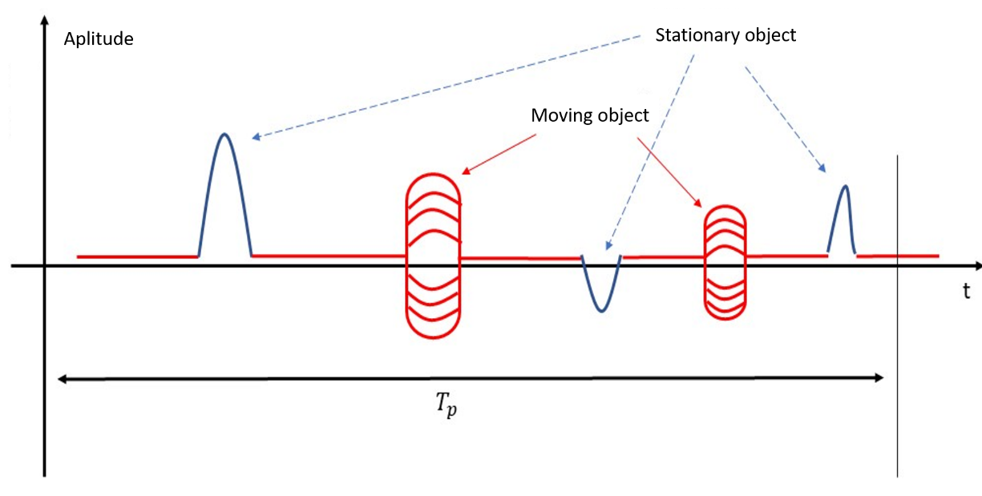

Figure : The relation between signal from the MTI system with Stationary and Moving Object

The Doppler radar Pulse system generally uses a medium and high PRF in which the system operates with a high PRF parameter that gives us clear information about the velocity, but is quite vague about the object gap information , for the system to operate with average PRF parameter gives us information about the distance as well as the velocity of the object in an unclear way.

**2.4.7 Phased - Array Radar**

For the radar systems mentioned, the antenna used in the system is usually set fixed with a defined radiation direction. Typically, the width of antennas used in radar is quite narrow to increase the accuracy of the identification of objects. However, it makes it difficult for the radar to observe large areas, so the antenna system designed with rotate capability to operate in the wider space. The mechanical-based rotating antenna design makes the radar system work with a very high latency (due to the use of the motor to rotate the antenna) which can result in the loss of information and the system becoming more cumbersome.

Today, with the advance of the antenna system, the antenna system is paired from small antennas, simple in two-dimensional or 3-dimensional structure-it is possible to create a radar system that works in all directions although the antenna is still set to fixed.

Depending on the phase difference in each antenna, we change the radiation direction of the antenna system so that helping to change the direction of the antenna without the need to rotate the antenna. The advantage of the array antenna is that it is possible to help change the orientation of the antenna wave even though the antenna remains fixed thereby reducing the bulky compared to the rotating antenna system. In addition, the speed of change the orientation of the antenna in the system using antennas can be achieved very high, thus limiting the signal loss due to the mechanical latency caused.

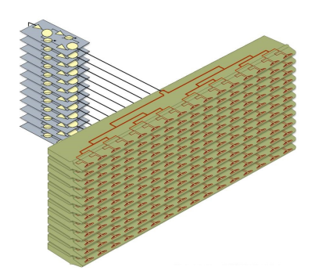

Figure : Array antenna system

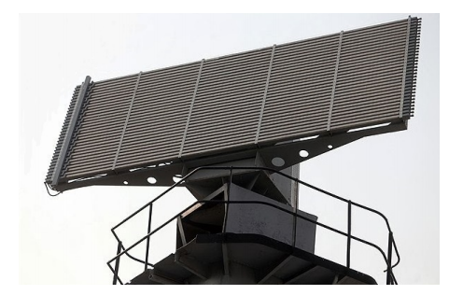

Figure : Array radar system

|  |  |  |
| --- | --- | --- |
|  | Dãy tần chuẩn | Dãy tần phân chia dựa theo ITU |
| HF | 3 ÷ 30 [MHz] |  |
| VHF | 30 ÷ 300 [MHz] | 138 ÷ 144 [MHz] , 216 ÷ 255 [MHz] |
| UHF | 300 ÷ 1000 [MHz] | 420 ÷ 450 [MHz], 890 ÷ 942 [MHz] |
| L | 1.0 ÷ 2.0 [GHz] | 1215 ÷ 1400 [MHz] |
| S | 2.0 ÷ 4.0 [GHz] | 2.3 ÷ 2.5 [GHz], 2.7 ÷ 3.7 [GHz] |
| C | 4.0 ÷ 8.0 [GHz] | 4.2 ÷ 4.4 [GHz], 5.25 ÷ 5.925 [GHz] |
| X | 8.0 ÷ 12.0 [GHz] | 8.5 ÷ 10.68 [GHz] |
| $$K_{u}$$ | 12.0 ÷ 18.0 [GHz] | 13.4 ÷ 14 [GHz], 15.7 ÷ 17.7 [GHz] |
| K | 18.0 ÷ 27.0 [GHz] | 24.05 ÷ 24.25 [GHz], 24.65 ÷ 24.75 [GHz] |
| $$K_{a}$$ | 27.0 ÷ 40.0 [GHz] | 33.4 ÷ 36 [GHz] |
| V | 40.0 ÷ 75.0 [GHz] | 59.0 ÷ 64.0 [GHz] |
| W | 75 ÷ 110.0 [GHz] | 76.0 ÷ 81.0 [GHz], 92.0 ÷ 100 [GHz] |

**2.5 Frequency ranges of radar**

**HF (3 ÷ 30 [MHz]:):** The majority of the radar that operates in the HF frequency range is used to identify objects at a very distant distance (greater than 3700 km-2000 nautical mile) since the HF electromagnetic waves are refraction very well when passing through the level of the electrolyte.

The objectives of the radar operating in HF bands are often helicopters, marine vessels, and ballistic missiles. In addition, the radar types mentioned are also used to collect reflections from the surface of the oceans, thereby collecting information about the direction as well as the speed of the wind surfing on the surface of the sea.

**VHF (30 ÷ 300 [MHz]:)** The first radar system was built in the years 1930 operating in VHF bands. At that time VHF band was considered the highest band for which radar technology could be reached. The frequency of radar waves in this band is suitable for applications such as the Air Surveillance system or the determination of ballistic missiles. At this band, the coefficient of reflection on the ground is quite high especially for the water surface, so the interference between direct reflection and reflex waves from the surface greatly increases the range of radar systems in the band Vhf. However, wave interference is always a problem besides the wave resonance that is the wave suppression at the point of the node. As such, in the case of the suppressed signal will greatly affect the performance of the radar.

In addition, the cost of radar in the VHF band is also lower than that of the higher bands with and range.

**UHF (300 ÷ 1000 [MHz]:)** Features of the radar system operating at VHF bands are also extended to operate at UHF bands. This type of radar is usually designed to operate in UHF bands which are MTI (Moving-Target Indication) radar. In addition, the UHF band is also suitable for designing radar systems that operate at long range such as defining and monitoring satellites or ballistic missiles. In particular, the UHF frequency range is used for Air Surveillance or the radar capable of surveying direction as well as the speed of the airflow.

**L Band (1.0 ÷ 2.0 [GHz]:)** L frequency range well suited for Air surveillance radar. However, in the higher frequency range, the effects of weather to the signal will higher. Therefore, the design of the radar in the frequency range L have to attention to minimizing the impact of weather on the quality of the radar. In addition, radar operating in this frequency range is also used to determine the satellite or the missiles fired at distances between continents (intercontinental - intercontinental ballistic missile).

**S Band (2.0 ÷ 4.0 [GHz]:)** Operating range of the radar system in the S-band at about 50 per nautical and especially 3-dimensional radar systems. As we all know that the low frequency range suitable for long-range surveillance radar, however high accuracy in determining the object location operating at high frequency ranges. S-band radar provides an optimal compromise on both abilities to work in the same radar system has been mentioned.

The radar for weather observations are often designed in band S. The reason is because at lower frequencies, the signal power level received on relatively weak reflections, while at higher frequencies, the signal spreads transmission attenuated rapidly and therefore cause significant error in determining the information about the weather. There are many types of weather observation radars are designed to operate at higher frequencies, but generally operating short range than radars designed in band S.

**C Band (4.0 ÷ 8.0 [GHz]:)** The C-band is located between the S-band and the X-band, so the radars are designed in C-band with attributes such as those operating in the S and X bands. Previously, many applications were implemented on radar systems operating in C Band, however today the applications are executed in the active radar either at the S band or in the X band.

**X Band (8.0 ÷ 12.0 [GHz]:)** X-Band is commonly used for military application radars. Radar operated at the X-band was used for military airless aircraft as intercept, combat, or attack on ground objects. In particular, X-band is commonly used for radar-defining object images (imaging radar) on the SAR or ISAR principle. In addition, the X band is also suitable for the design of ocean exploration radar, an aircraft radar in order to minimize the impact of the.

**Ku, K, Ka Band (12.0 ÷ 40.0 [GHz]:)** The higher the frequency signal is, the greater the antenna size that is designed for that signal decreases, which makes it difficult to create a large level of transmitter. As a result, the range of radars operating in higher band X-band is generally lower than that of X-band operation. This band is used for small-size radars with short range of activity.

**2.6 Application of Radar**

**Introduction of IWR1642**

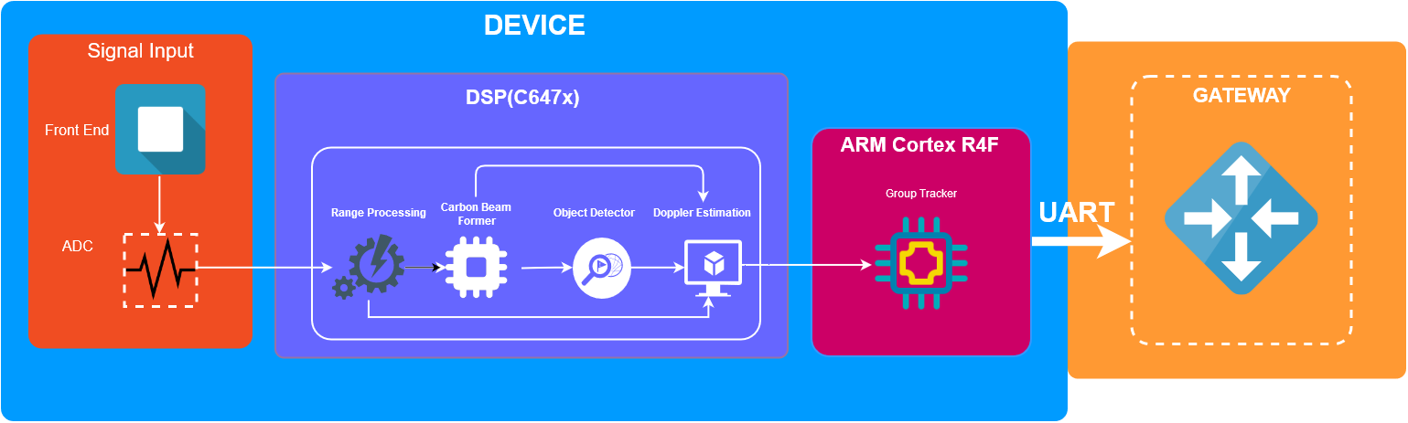

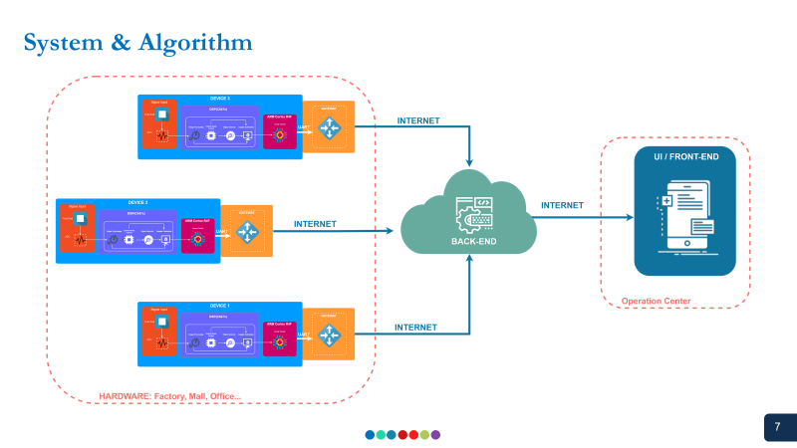

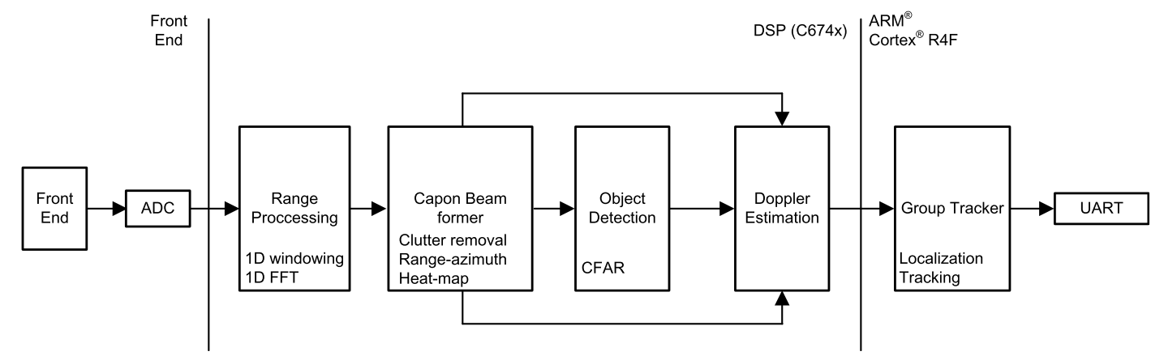

the implementation of the people-counting application demo on the IWR6843 consists of a signal chain running on the C674x DSP, and the tracking module running on the ARM® Cortex®-R4F processor.

* Range processing: – For each antenna, 1D windowing, and 1D fast Fourier transform (FFT) – Range processing is interleaved with the active chirp time of the frame
* Capon beam forming: – Static clutter removal – Covariance matrix generation, inverse-angle spectrum generation, and integration is performed – Outputs range-angle heat map
* CFAR detection algorithm: – Two-pass, constant false-alarm rate – First pass cell averaging smallest of CFAR-CASO in the range domain, confirmed by second pass cell averaging smallest of CFAR-CASO in the angle domain, to find detection points.
* Doppler estimation: – For each detected [range, azimuth] pair from the detection module, estimate the Doppler by filtering the range bin using Capon beam-weights, and then run a peak search over the FFT of the filtered range bin.
* Tracking: – Perform target localization, and report the results. – Output of the tracker is a set of trackable objects with certain properties like position, velocity, physical dimensions, and point density

**Idea installing the system**

The system have two board the IWR1642 and the Raspberry PI 3. The Idea is to connect the IWR1642 with the Raspberry Pi in order to let the Raspberry auto config and upload the data (Wifi) to the server via MQTT protocol.

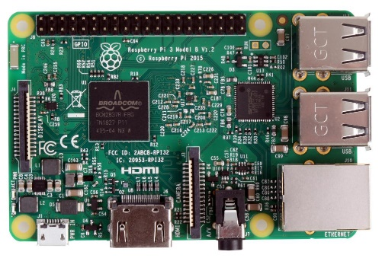 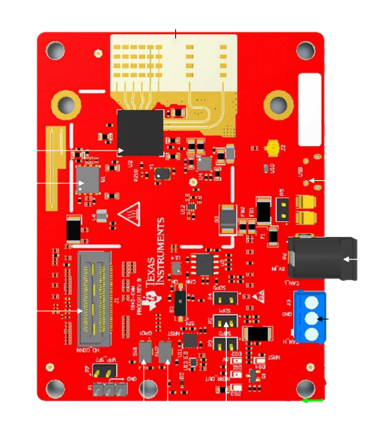

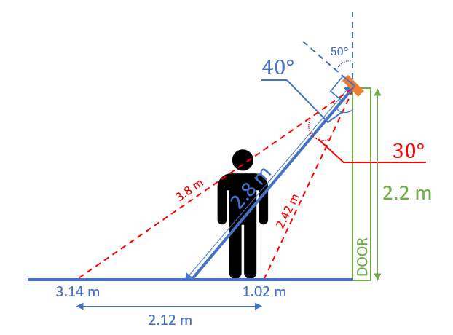

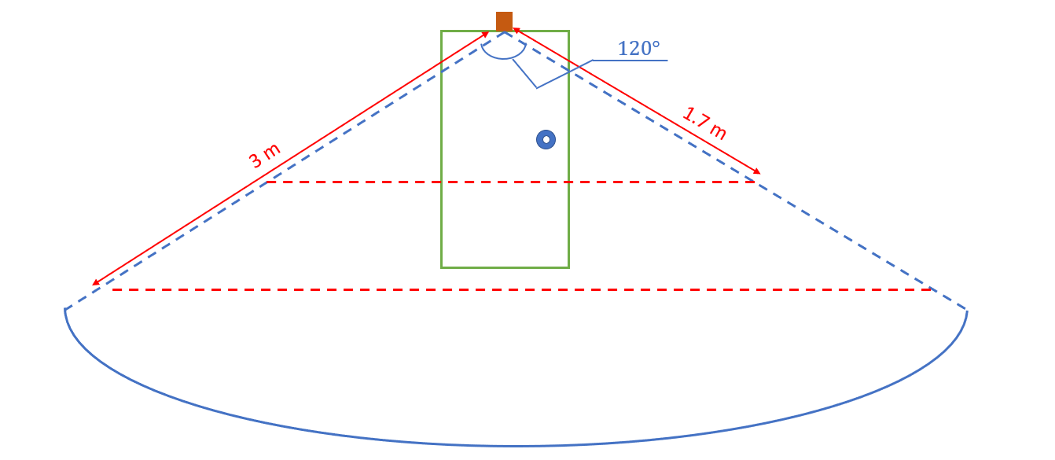

**Data Formats**

A TLV (type-length-value) encoding scheme is used with little endian byte order. For every frame, a packet is sent consisting of a fixed sized Frame Header and then a variable number of TLVs depending on what was detected in that scene. The TLVs can be of types representing the 2D point cloud, target list object, and associated points.

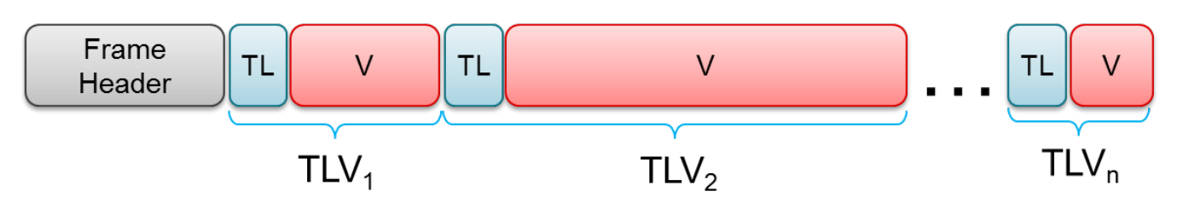

**Frame Header (52 bytes)**

The frame header is a fixed size (52 bytes) and has following structure (using MATLAB® notation, with name, type, and length in bytes). The header is designed to self-describe the content, and allow the user application to operate in a lossy environment. The header fields are protected with the checksum,

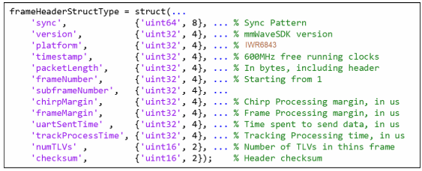

**TLVs**

The TLVs can be of type **POINT_CLOUD_2D**, **TARGET_LIST_2D**, or **TARGET_INDEX**.

**TLV Header (8 bytes)**

Each TLV has a fixed header (8 bytes) followed by a TLV-specific payload. Figure 11 shows the TLV header.

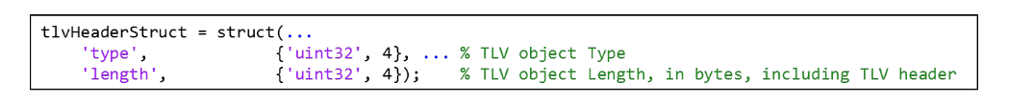

Three TLVs are supported at this time, as follows:

• Point cloud TLV

– Type = POINT_CLOUD_2D

– Length = sizeof (tlvHeaderStruct) + sizeof (pointStruct2D) × numberOfPoints

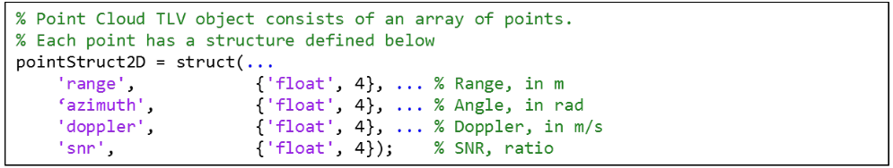

• Target list TLV

– Type = TARGET_LIST_2D

– Length = sizeof (tlvHeaderStruct) + sizeof (targetStruct) × numberOfTargets

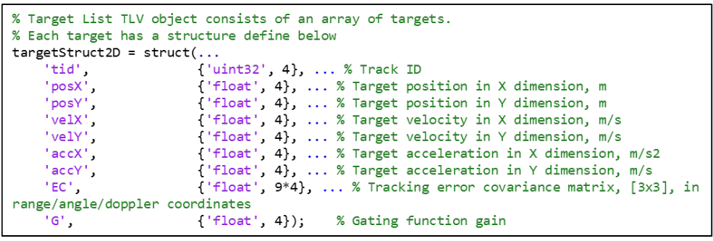

• Target Index TLV

– Type = TARGET_INDEX

– Length = sizeof (tlvHeaderStruct) + numberOfPoints.

– Payload is a byte array, each byte represents a tracking ID.

**NOTE**: The target index TLV received in the N-th frame indices the point cloud in (N-1)-th frame.

The txrack ID is a byte. Values 0 to 249 are supported. Values 250 to 255 are reserved.

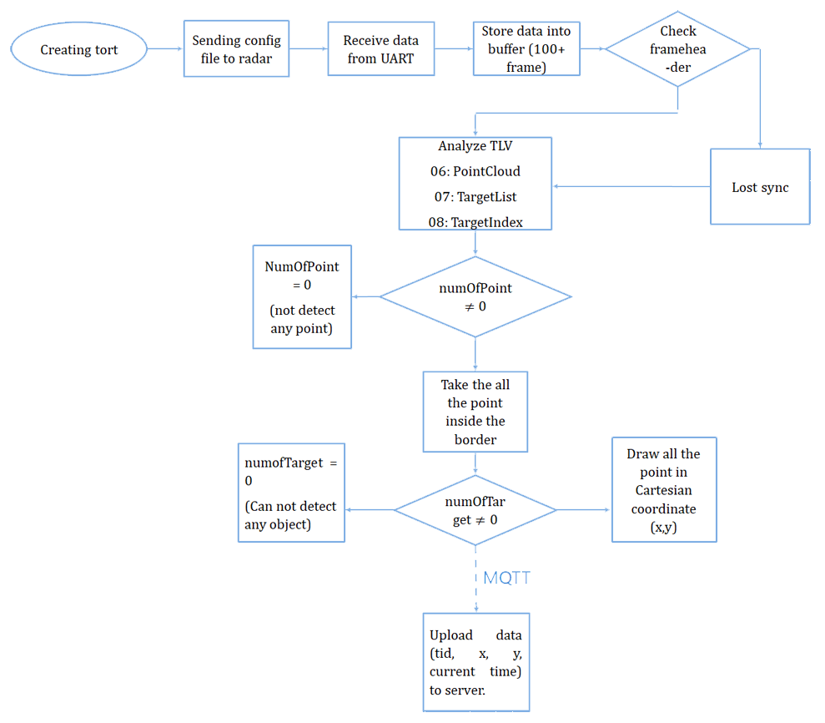

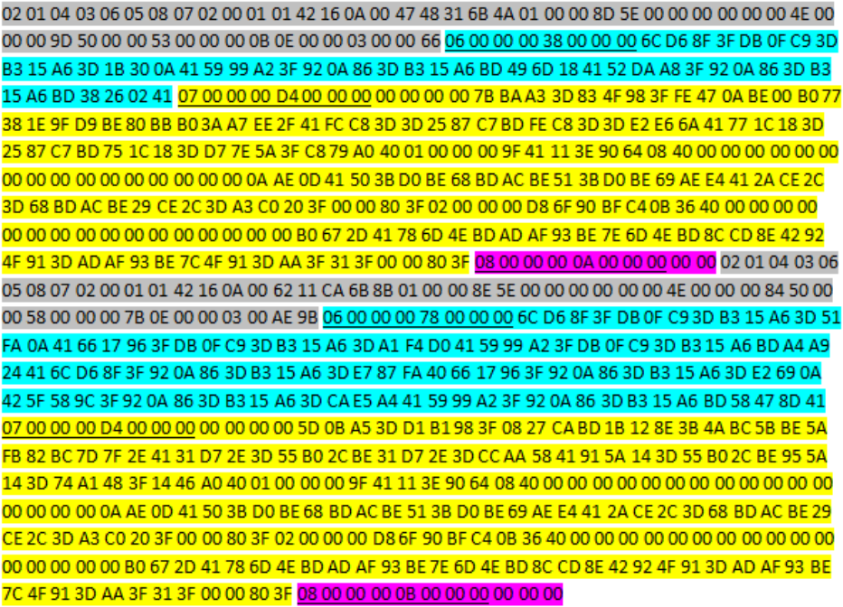

Frame Header

Point Cloud TLV

Target List TLV

Target Index TLV

Type Length Header

***For the Frame Header***

* Sync byte of the first frame: 02 01 04 03 06 05 08 07
* Vesion: byte 13 đến byte 16 (42 16 0A 00)
* Packet length: from byte 21 to byte 24 (4A 01 00 00) convert to unit32 which equal 330
* Framenumber: 8D 5E 00 00
* numTLVs: 03 00 (which mean it contain 3 types of TLV: pointCloud_TLV, targetList_TLV, targetIndex_TLV)

***For the pointCloud_TLV:***

PointCloud_TLVheader: 06 00 00 00 38 00 00 00 (06 is an TLV type, 338 is the length of of PointCloud_TLV, which converted to Hex equal 56)

If we remove the length of the header we will have the PointStruct2D = 56 – 8 = 48 bytes.

Each PointStruct2D have the length of 16 bytes, so $\frac{48}{16}=3$ (numberOfPoint)

Consider 16 bytes of the first PointStruct2D (Float 32 bit converted):

* Range: 6C D6 8F 3F

The distance estimated: 1.1237 (m)

* Azimuth: DB 0F C9 3D

The angle estimated: 0.0982 (rad)

* Doppler: B3 15 A6 3D

The Doppler estimated: 0.0811 (m/s)

* SNR: 1B 30 0A 41

The SNR estimated: 8.6367

Consider the next 16 bytes of the second PointStruct2D (Float 32 bit converted):

* Range: 59 99 A2 3F

The distance estimated: 1.2703 (m)

* Azimuth: 92 0A 86 3D

The angle estimated: 0.0654 (rad)

* Doppler: B3 15 A6 BD

The Doppler estimated: -0.0811 (m/s)

* SNR: 49 6D 18 41

The SNR estimated: 9.5267

Consider the last 16 bytes of the third PointStruct2D (Float 32 bit converted):

* Range: 52 DA A8 3F

The distance estimated: 1.3192 (m)

* Azimuth: 92 0A 86 3D

The angle estimated: 0.0654 (rad)

* Doppler: B3 15 A6 BD

The Doppler estimated: -0.0811 (m/s)

* SNR: 38 26 02 41

The SNR estimated: 8.1343

***For the targetList_TLV:***

* Type_TLV: 07 (which is an TLV type)

The Length of the PointCloud_TLV: D4 which convert to HEX equal 212.

If we remove the header we will have the targetStruct= 212 – 8 = 204 bytes.

Each targetStruct have the fixed length is 68 bytes so $\frac{204}{68} = 3$ (numberOfTarget)

Consider the first targetStruct:

* Track ID: 00 00 00 00

Which is an ID of the target (ID = 0)

* PosX: 7B BA A3 3D

The X coordinate of the target = 0.0799 (m)

* PosY: 83 4F 98 3F

The Y coordinate of the target = 1.1899 (m)

* VelX: FE 47 0A BE

The velocity base on X coordinate of the target = -0.135 (m/s)

* VelY: 00 B0 77 38

The velocity base on Y coordinate of the target = $5.9×{10}^{-5}$ (m/s)

* AccX: 1E 9F D9 BE

The acceleration base on X coordinate of the target = -0.425 (𝑚/𝑠2)

* AccY: 80 BB B0 3A

The acceleration base on Y coordinate of the target = 0.0013 (m/s2)

* Gaiting: C8 79 A0 40

Gaiting that combine with the PointCloud = 5.0149

We examine the same with the other TargetStruct.

**THE RESULT OF THE PEOPLE COUNTING APPLICATION IN PYTHON**

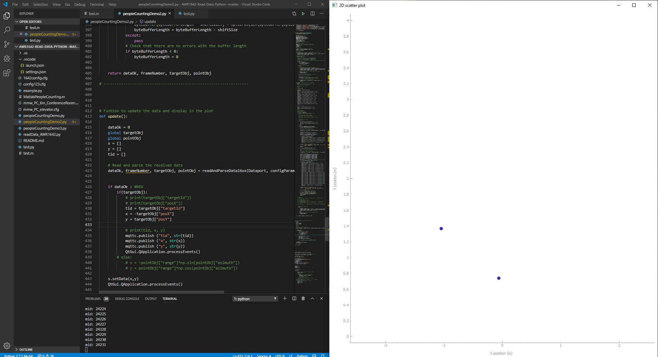

The output data we want is:

X, Y, tid (target ID that maximum is 20 target from 0 -> 20), Date&Time

**Source Code**

import serial

import time

import numpy as np

import paho.mqtt.client as mqtt

import datetime

import pyqtgraph as pg

from pyqtgraph.Qt import QtGui

#Setting for currentime

#----------------------------------------------------------------------

datetime.datetime.now()

datetime.datetime(2009, 1, 6, 15, 8, 24)

#----------------------------------------------------------------------

# MQTTconfig

#----------------------------------------------------------------------

broker_url = "soldier.cloudmqtt.com"

broker_port = 11141

username = "spoeosqs"

password = "ac_554KtH4Gr"

mqttc = mqtt.Client()

mqttc.username_pw_set (username, password)

mqttc.connect(broker_url,broker_port)

# Define event callbacks

def on_connect(client, userdata, flags, rc):

    print("rc: " + str(rc))

def on_message(client, obj, msg):

    print(msg.topic + " " + str(msg.qos) + " " + str(msg.payload))

def on_publish(client, obj, mid):

    print("mid: " + str(mid))

# Assign event callbacks

mqttc.on_message = on_message

mqttc.on_connect = on_connect

mqttc.on_publish = on_publish

#-----------------------------------------------------------------

# Change the configuration file name

configFileName = 'mmw_PC_elevator.cfg'

CLIport = {}

Dataport = {}

byteBuffer = np.zeros(2**15,dtype = 'uint8')

byteBufferLength = 0;

# -----------------------------------------------------------------------------

# -----------------------------------------------------------------------------

# -----------------------------------------------------------------------------

# Function to configure the serial ports and send the data from

# the configuration file to the radar

def serialConfig(configFileName):

    global CLIport

    global Dataport

    # Open the serial ports for the configuration and the data ports

    # Raspberry pi

    # CLIport = serial.Serial('/dev/ttyACM0', 115200)

    # Dataport = serial.Serial('/dev/ttyACM1', 921600)

    # Windows

    CLIport = serial.Serial('COM4', 115200)

    Dataport = serial.Serial('COM3', 921600)

    # Read the configuration file and send it to the board

    config = [line.rstrip('\r\n') for line in open(configFileName)]

    for i in config:

        CLIport.write((i+'\n').encode())

        print(i)

        time.sleep(0.01)

    return CLIport, Dataport

# -----------------------------------------------------------------------------

# -----------------------------------------------------------------------------

# -----------------------------------------------------------------------------

# Function to parse the data inside the configuration file

def parseConfigFile(configFileName):

    configParameters = {} # Initialize an empty dictionary to store the configuration parameters

    # Read the configuration file and send it to the board

    config = [line.rstrip('\r\n') for line in open(configFileName)]

    for i in config:

        # Split the line

        splitWords = i.split(" ")

        # Hard code the number of antennas, change if other configuration is used

        numRxAnt = 4

        numTxAnt = 2

        # Get the information about the profile configuration

        if "profileCfg" in splitWords[0]:

            startFreq = int(float(splitWords[2]))

            idleTime = int(splitWords[3])

            rampEndTime = float(splitWords[5])

            freqSlopeConst = float(splitWords[8])

            numAdcSamples = int(splitWords[10])

            digOutSampleRate = int(splitWords[11])

            numAdcSamplesRoundTo2 = 1;

            while numAdcSamples > numAdcSamplesRoundTo2:

                numAdcSamplesRoundTo2 = numAdcSamplesRoundTo2 * 2;

            digOutSampleRate = int(splitWords[11]);

        # Get the information about the frame configuration

        elif "frameCfg" in splitWords[0]:

            chirpStartIdx = int(splitWords[1]);

            chirpEndIdx = int(splitWords[2]);

            numLoops = int(splitWords[3]);

            numFrames = int(splitWords[4]);

            framePeriodicity = int(splitWords[5]);

    # Combine the read data to obtain the configuration parameters

    numChirpsPerFrame = (chirpEndIdx - chirpStartIdx + 1) * numLoops

    configParameters["numDopplerBins"] = numChirpsPerFrame / numTxAnt

    configParameters["numRangeBins"] = numAdcSamplesRoundTo2

    configParameters["rangeResolutionMeters"] = (3e8 * digOutSampleRate * 1e3) / (2 * freqSlopeConst * 1e12 * numAdcSamples)

    configParameters["rangeIdxToMeters"] = (3e8 * digOutSampleRate * 1e3) / (2 * freqSlopeConst * 1e12 * configParameters["numRangeBins"])

    configParameters["dopplerResolutionMps"] = 3e8 / (2 * startFreq * 1e9 * (idleTime + rampEndTime) * 1e-6 * configParameters["numDopplerBins"] * numTxAnt)

    configParameters["maxRange"] = (300 * 0.9 * digOutSampleRate)/(2 * freqSlopeConst * 1e3)

    configParameters["maxVelocity"] = 3e8 / (4 * startFreq * 1e9 * (idleTime + rampEndTime) * 1e-6 * numTxAnt)

    return configParameters

# -----------------------------------------------------------------------------

# -----------------------------------------------------------------------------

# -----------------------------------------------------------------------------

# Funtion to read and parse the incoming data

def readAndParseData16xx(Dataport, configParameters):

    global byteBuffer, byteBufferLength

    # Constants

    OBJ_STRUCT_SIZE_BYTES = 12;

    BYTE_VEC_ACC_MAX_SIZE = 2**15;

    MMWDEMO_UART_MSG_POINT_CLOUD_2D = 6;

    MMWDEMO_UART_MSG_TARGET_LIST_2D = 7;

    MMWDEMO_UART_MSG_TARGET_INDEX_2D = 8;

    maxBufferSize = 2**15;

    tlvHeaderLengthInBytes = 8;

    pointLengthInBytes = 16;

    targetLengthInBytes = 68;

    magicWord = [2, 1, 4, 3, 6, 5, 8, 7]

    # Initialize variables

    magicOK = 0 # Checks if magic number has been read

    dataOK = 0 # Checks if the data has been read correctly

    frameNumber = 0

    targetObj = {}

    pointObj = {}

    #read buffer from the board

    readBuffer = Dataport.read(Dataport.in_waiting)

    byteVec = np.frombuffer(readBuffer, dtype = 'uint8')     # interpret the buffer in an array

    byteCount = len(byteVec)                                 # Count number in the array

    # Check that the buffer is not full, and then add the data to the buffer

    if (byteBufferLength + byteCount) < maxBufferSize:

        byteBuffer[byteBufferLength:byteBufferLength + byteCount] = byteVec[:byteCount]

        byteBufferLength = byteBufferLength + byteCount

    # Check that the buffer has some data

    if byteBufferLength > 16:

        # Check for all possible locations of the magic word

        possibleLocs = np.where(byteBuffer == magicWord[0])[0]

        # Confirm that is the beginning of the magic word and store the index in startIdx

        startIdx = []

        for loc in possibleLocs:

            check = byteBuffer[loc:loc + 8]

            if np.all(check == magicWord):

                startIdx.append(loc)

        # Check that startIdx is not empty

        if startIdx:

            # Remove the data before the first start index

            if startIdx[0] > 0 and startIdx[0] < byteBufferLength:

                byteBuffer[:byteBufferLength - startIdx[0]] = byteBuffer[startIdx[0]:byteBufferLength]

                byteBuffer[byteBufferLength-startIdx[0]:] = np.zeros(len(byteBuffer[byteBufferLength-startIdx[0]:]),dtype = 'uint8')

                byteBufferLength = byteBufferLength - startIdx[0]

            # Check that there have no errors with the byte buffer length

            if byteBufferLength < 0:

                byteBufferLength = 0

            # word array to convert 4 bytes to a 32 bit number

            word = [1, 2 ** 8, 2 ** 16, 2 ** 24]

            # Read the total packet length

            # Truong code

            totalPacketLen = np.matmul(byteBuffer[20:20 + 4], word)

            # totalPacketLen = np.matmul(byteBuffer[12:12 + 4], word)

            # Check that all the packet has been read

            if (byteBufferLength >= totalPacketLen) and (byteBufferLength != 0):

                magicOK = 1

    # If magicOK is equal to 1 then process the message

    if magicOK:

        # word array to convert 4 bytes to a 32 bit number

        word = [1, 2 ** 8, 2 ** 16, 2 ** 24]

        # Initialize the pointer index

        idX = 0

        # Read the header

        magicNumber = byteBuffer[idX:idX + 8]

        idX += 8

        version = format(np.matmul(byteBuffer[idX:idX + 4], word), 'x')

        idX += 4

        platform = format(np.matmul(byteBuffer[idX:idX + 4], word), 'x')

        idX += 4

        timeStamp = np.matmul(byteBuffer[idX:idX + 4], word)

        idX += 4

        totalPacketLen = np.matmul(byteBuffer[idX:idX + 4], word)

        idX += 4

        frameNumber = np.matmul(byteBuffer[idX:idX + 4], word)

        idX += 4

        subFrameNumber = np.matmul(byteBuffer[idX:idX + 4], word)

        idX += 4

        chirpMargin = np.matmul(byteBuffer[idX:idX + 4], word)

        idX += 4

        frameMargin = np.matmul(byteBuffer[idX:idX + 4], word)

        idX += 4

        uartSentTime = np.matmul(byteBuffer[idX:idX + 4], word)

        idX += 4

        trackProcessTime = np.matmul(byteBuffer[idX:idX + 4], word)

        idX += 4

        word = [1, 2 ** 8]

        numTLVs = np.matmul(byteBuffer[idX:idX + 2], word)

        idX += 2

        checksum = np.matmul(byteBuffer[idX:idX + 2], word)

        idX += 2

        # print (byteBuffer)

        # print (numTLVs)

        # Read the TLV messages

        for tlvIdx in range(numTLVs):

        # word array to convert 4 bytes to a 32 bit number

            word = [1, 2 ** 8, 2 ** 16, 2 ** 24]

            # # Check the header of the TLV message

            # tlv_type = np.matmul(byteBuffer[idX:idX + 4], word)

            # idX += 4

            # tlv_length = np.matmul(byteBuffer[idX:idX + 4], word)

            # idX += 4

            # Initialize the tlv type

            tlv_type = 0

            try:

            # Check the header of the TLV message#######################################################################################

                tlv_type = np.matmul(byteBuffer[idX:idX + 4], word)

                idX += 4

                tlv_length = np.matmul(byteBuffer[idX:idX + 4], word)

                idX += 4

            except:

                pass

            # Read the data depending on the TLV message

            if tlv_type == MMWDEMO_UART_MSG_POINT_CLOUD_2D: #######################################################################################

                # word array to convert 4 bytes to a 16 bit number

                word = [1, 2 ** 8, 2 ** 16, 2 ** 24]

                # Calculate the number of detected points

                numInputPoints = (tlv_length - tlvHeaderLengthInBytes) // pointLengthInBytes

                # Initialize the arrays

                rangeVal = np.zeros(numInputPoints, dtype=object)

                #truongCODE

                azimuth = np.zeros(numInputPoints, dtype=object)

                dopplerVal = np.zeros(numInputPoints, dtype=object)

                snr = np.zeros(numInputPoints, dtype=object)

                for objectNum in range(numInputPoints):

                    # Read the data for each object

                    rangeVal[objectNum] = byteBuffer[idX:idX + 4].view(dtype=np.float32)

                    idX += 4

                    azimuth[objectNum] = byteBuffer[idX:idX + 4].view(dtype=np.float32)

                    idX += 4

                    dopplerVal[objectNum] = byteBuffer[idX:idX + 4].view(dtype=np.float32)

                    idX += 4

                    snr[objectNum] = byteBuffer[idX:idX + 4].view(dtype=np.float32)

                    idX += 4

                    # Store the data in the detObj dictionary

                pointObj = {"numObj": numInputPoints, "range": rangeVal, "azimuth": azimuth,\

                            "doppler": dopplerVal, "snr": snr}

                # print(pointObj)

                dataOK = 1

            elif tlv_type == MMWDEMO_UART_MSG_TARGET_LIST_2D:

                # word array to convert 4 bytes to a 16 bit number

                word = [1, 2 ** 8, 2 ** 16, 2 ** 24]

                # Calculate the number of target points

                numTargetPoints = (tlv_length - tlvHeaderLengthInBytes) // targetLengthInBytes

                # Initialize the arrays

                targetId = np.zeros(numTargetPoints, dtype=np.uint32)

                posX = np.zeros(numTargetPoints, dtype=np.float32)

                posY = np.zeros(numTargetPoints, dtype=np.float32)

                velX = np.zeros(numTargetPoints, dtype=np.float32)

                velY = np.zeros(numTargetPoints, dtype=np.float32)

                accX = np.zeros(numTargetPoints, dtype=np.float32)

                accY = np.zeros(numTargetPoints, dtype=np.float32)

                #TruongCODE

                EC = np.zeros((3, 3, numTargetPoints), dtype=object)  # Error covariance matrix np

                G = np.zeros(numTargetPoints, dtype=object)  # Gain

                for objectNum in range(numTargetPoints):

                # Read the data for each object

                    try:

                        targetId[objectNum] = np.matmul(byteBuffer[idX:idX + 4], word)

                        idX += 4

                        posX[objectNum] = byteBuffer[idX:idX + 4].view(dtype=np.float32)

                        idX += 4

                        posY[objectNum] = byteBuffer[idX:idX + 4].view(dtype=np.float32)

                        idX += 4

                        velX[objectNum] = byteBuffer[idX:idX + 4].view(dtype=np.float32)

                        idX += 4

                        velY[objectNum] = byteBuffer[idX:idX + 4].view(dtype=np.float32)

                        idX += 4

                        accX[objectNum] = byteBuffer[idX:idX + 4].view(dtype=np.float32)

                        idX += 4

                        accY[objectNum] = byteBuffer[idX:idX + 4].view(dtype=np.float32)

                        idX += 4

                        EC[0, 0, objectNum] = byteBuffer[idX:idX + 4].view(dtype=np.float32)

                        idX += 4

                        EC[0, 1, objectNum] = byteBuffer[idX:idX + 4].view(dtype=np.float32)

                        idX += 4

                        EC[0, 2, objectNum] = byteBuffer[idX:idX + 4].view(dtype=np.float32)

                        idX += 4

                        EC[1, 0, objectNum] = byteBuffer[idX:idX + 4].view(dtype=np.float32)

                        idX += 4

                        EC[1, 1, objectNum] = byteBuffer[idX:idX + 4].view(dtype=np.float32)

                        idX += 4

                        EC[1, 2, objectNum] = byteBuffer[idX:idX + 4].view(dtype=np.float32)

                        idX += 4

                        EC[2, 0, objectNum] = byteBuffer[idX:idX + 4].view(dtype=np.float32)

                        idX += 4

                        EC[2, 1, objectNum] = byteBuffer[idX:idX + 4].view(dtype=np.float32)

                        idX += 4

                        EC[2, 2, objectNum] = byteBuffer[idX:idX + 4].view(dtype=np.float32)

                        idX += 4

                        G[objectNum] = byteBuffer[idX:idX + 4].view(dtype=np.float32)

                        idX += 4

                    except:

                        pass

                # Store the data in the detObj dictionary

                targetObj = {"targetId": targetId, "posX": posX, "posY": posY, \

                             "velX": velX, "velY": velY, "accX": accX, "accY": accY, \

                             "EC": EC, "G": G}

            elif tlv_type == MMWDEMO_UART_MSG_TARGET_INDEX_2D: #######################################################################################

                # Calculate the length of the index message

                numIndices = tlv_length - tlvHeaderLengthInBytes

                indices = byteBuffer[idX:idX + numIndices]

                idX += numIndices

                dataOK = 1

        # Remove already processed data

        if idX > 0:

            try:

                shiftSize = totalPacketLen     # try change idX to totalPacketLen

                byteBuffer[:byteBufferLength - shiftSize] = byteBuffer[shiftSize:byteBufferLength]

                byteBuffer[byteBufferLength - shiftSize:] = np.zeros(len(byteBuffer[byteBufferLength - shiftSize:]),dtype = 'uint8') #NEW

                byteBufferLength = byteBufferLength - shiftSize

            except:

                pass

            # Check that there are no errors with the buffer length

            if byteBufferLength < 0:

                byteBufferLength = 0

    return dataOK, frameNumber, targetObj, pointObj

# ------------------------------------------------------------------

# Funtion to update the data and display in the plot

def update():

    dataOk = 0

    global targetObj

    global pointObj

    global mqttCount

    x = []

    y = []

    tid = []

    # Read and parse the received data

    dataOk, frameNumber, targetObj, pointObj = readAndParseData16xx(Dataport, configParameters)

    if dataOk : #NEW

        if(targetObj):

            tid = targetObj["targetId"]

            x = -targetObj["posX"]

            y = targetObj["posY"]

            tid_comma = list(tid)

            x_comma = list(x)

            y_comma = list (y)

            if mqttCount == 10:

                mqttc.publish ("date & time", str(datetime.datetime.now()))

                mqttc.publish ("tid", str(tid_comma))

                mqttc.publish ("x", str(x_comma))

                mqttc.publish ("y", str(y_comma))

                mqttCount = 0

            else:

                mqttCount = mqttCount + 1

            QtGui.QApplication.processEvents()

    s.setData(x,y)

    QtGui.QApplication.processEvents()

    return dataOk

# -----------------------------------------------------------------------------

# -------------------------    MAIN   -----------------------------------------

# -----------------------------------------------------------------------------

# Configurate the serial port

CLIport, Dataport = serialConfig(configFileName)

# Get the configuration parameters from the configuration file

configParameters = parseConfigFile(configFileName)

#START QtAPPfor the plot

app = QtGui.QApplication([])

# Set the plot

pg.setConfigOption('background','w')

win = pg.GraphicsWindow(title="2D scatter plot")

p = win.addPlot()

p.setXRange(-2.5,2.5)

p.setYRange(0,4)

p.setLabel('left',text = 'Y position (m)')

p.setLabel('bottom', text= 'X position (m)')

s = p.plot([],[],pen=None,symbol='o')

# Main loop

targetObj = {}

pointObj = {}

frameData = {}

mqttCount = 0

currentIndex = 0

while True:

    try:

        # Update the data and check if the data is okay

        dataOk = update()

        if dataOk:

            # Store the current frame into frameData

            frameData[currentIndex] = targetObj

            currentIndex += 1

            # print(targetObj["posX"])

        time.sleep(0.044) # Sampling frequency of 30 Hz

    # Stop the program and close everything if Ctrl + c is pressed

    except KeyboardInterrupt:

        # CLIport.write(('sensorStop\n').encode())

        CLIport.close()

        Dataport.close()

        # win.close()

        break

**MQTT DEFINITION**

MQTT is one of the most commonly used protocols in IoT projects. It stands for Message Queuing Telemetry Transport.

In addition, it is designed as a lightweight messaging protocol that uses publish/subscribe operations to exchange data between clients and the server. Furthermore, its small size, low power usage, minimized data packets and ease of implementation make the protocol ideal of the “machine-to-machine” or “Internet of Things” world.

**WHY USE MQTT ?**

MQTT has unique features you can hardly find in other protocols, like:

* It’s a lightweight protocol. So, it’s easy to implement in software and fast in data transmission.
* It’s based on a messaging technique. Of course, you know how fast your messenger/WhatsApp message delivery is. Likewise, the MQTT protocol.
* Minimized data packets. Hence, low network usage.
* Low power usage. As a result, it saves the connected device’s battery.
* It’s real time! That’s is specifically what makes it perfect for IoT applications.

**HOW MQTT WORKS?**

MQTT is based on clients and a server. Likewise, the server is the guy who is responsible for handling the client’s requests of receiving or sending data between each other.

MQTT server is called a broker and the clients are simply the connected devices.  
So:

* When a device (a client) wants to send data to the broker, we call this operation a “publish”.
* When a device (a client) wants to receive data from the broker, we call this operation a “subscribe”.



**MQTT compare with HTTP**

**Design and Messaging**

MQTT is data centric whereas HTTP is document-centric. HTTP is request-response protocol for client-server computing and not always optimized for mobile devices. Main solid benefits of MQTT in these terms are lightweightness (MQTT transfers data as a byte array) and publish/subscribe model, which makes it perfect for resource-constrained devices and help to save battery.

Besides, publish/subscribe model provides clients with independent existence from one another and enhance the reliability of the whole system. When one client is out of order the whole system can keep on working properly.

**Speed and Delivery**

According to measurements in 3G networks, throughput of MQTT is 93 times faster than HTTP’s.

Besides, in comparison to HTTP, MQTT Protocol ensures high delivery guarantees. There are 3 levels of Quality of Services:

- at most once: guarantees a best effort delivery.

- at least once: guaranteed that a message will be delivered at least once. But the message can also be delivered more than once.

- exactly once: guarantees that each message is received only once by the counterpart

MQTT also provides users with options of Last will & Testament and Retained messages. The first means that in case of unexpected disconnection of a client all subscribed clients will get a message from a broker. Retained message means that a newly subscribed client will get an immediate status update.

HTTP Protocol has none of these abilities.

**Complexity and Message Size**  
  
MQTT (Message Queuing Telemetry Transport) has pretty short specification. There are only CONNECT, PUBLISH, SUBSCRIBE, UNSUBSCRIBE and DISCONNECT types that are significant for developers. Whereas HTTP specifications are much longer.

MQTT has a very short message header and the smallest packet message size of 2 bytes. Using text message format by HTTP protocol allows it to compose lengthy headers and messages. It helps to eliminate troubles because it can be read by humans, but at the same time it’s needless for resource-constrained devices.

**Conclusion**

MQTT Protocol is easy of use. It is essential when response time, throughput, lower battery and bandwidth usage are on the first place for future solutions. It’s also perfect in case of intermittent connectivity.

HTTP is worthy and extendable. But MQTT is more suitable when it is referred to IoT development.

**CloudMQTT Broker**

**CloudMQTT are managed Mosquitto servers in the cloud.** Mosquitto implements the MQ Telemetry Transport protocol, MQTT, which provides lightweight methods of carrying out messaging using a publish/subscribe message queueing model.

Also CloudMQTT broker does support **Heroku**

The result after upload the data into CloudMQTT

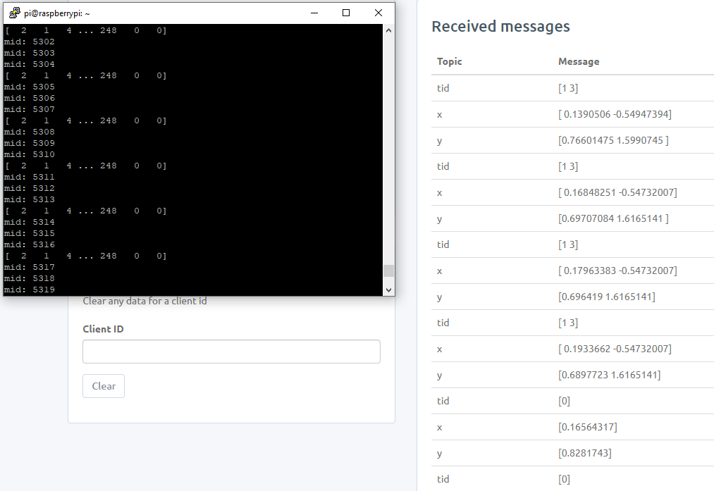

Let take the first group of data published

**tid = [1 3]**

which mean detect 2 target which the first target have an target id is 1 and the second target have target id is 3.

**x = [0.1390506 -0.57347394]**

**y = [0.76601475 1.5990745]**

which mean the fir target have the coordinate (0.1390506 , 0.76601475) and the second target have the coordinate (-0.57347394 , 1.5990745)

The LOG of publish data into server:

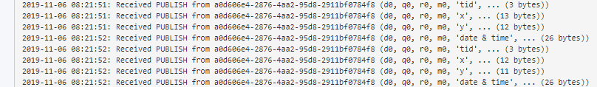

**Heroku**

Heroku deploy app



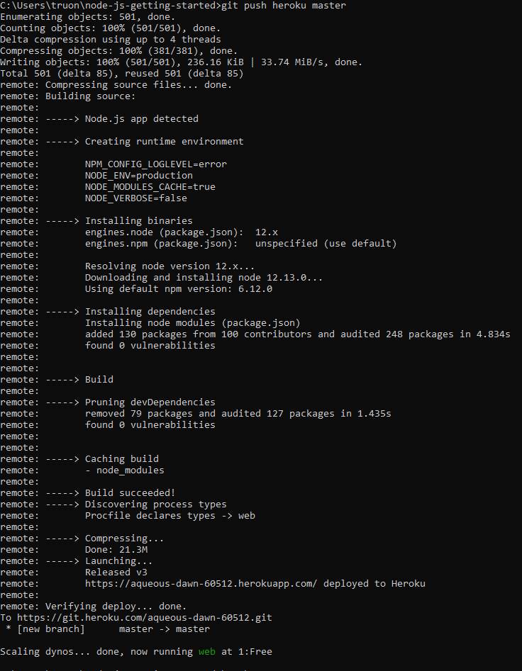

Check the app is running

heroku ps:scale web=1

View LOG

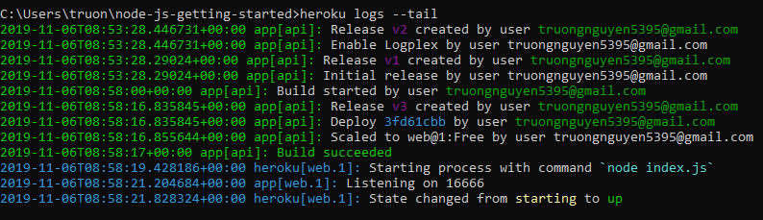

START A CONSOLE

To get a real feel for how dynos work, you can create another one-off dyno and run the bash command, which opens up a shell on that dyno. You can then execute commands there. Each dyno has its own ephemeral filespace, populated with your app and its dependencies - once the command completes (in this case, bash), the dyno is removed.

$ heroku run bash

Running `bash` attached to terminal... up, run.3052

~ $ ls

Procfile README.md composer.json composer.lock vendor views web

~ $ exit

exit

**PROCFILE**

Heroku apps include a **Procfile** that specifies the commands that are executed by the app on startup.

A Procfile declares its process types on individual lines, each with the following format:

<process type>: <command>

* <process type> is an alphanumeric name for your command, such as web, worker, urgentworker, clock, and so on.
* <command> indicates the command that every dyno of the process type should execute on startup, such as rake jobs:work.

**DYNO**

All Heroku applications run in a collection of lightweight Linux containers called **dynos**. This article describes dyno conventions on the Heroku platform

Every dyno belongs to one of the three following configurations:

* **Web**: Web dynos are dynos of the “web” process type that is defined in your [Procfile](https://devcenter.heroku.com/articles/procfile). Only web dynos receive HTTP traffic from the [routers](https://devcenter.heroku.com/articles/http-routing).
* **Worker**: Worker dynos can be of any process type declared in your Procfile, other than “web”. Worker dynos are typically used for background jobs, queueing systems, and timed jobs. You can have multiple kinds of worker dynos in your application. For example, one for urgent jobs and another for long-running jobs. For more information, see [Worker Dynos, Background Jobs and Queueing](https://devcenter.heroku.com/articles/background-jobs-queueing).
* **One-off**: One-off dynos are temporary dynos that can run detached, or with their input/output attached to your local terminal. They’re loaded with your latest release. They can be used to handle administrative tasks, such as database migrations and console sessions. They can also be used to run occasional background work, as with [Heroku Scheduler](https://devcenter.heroku.com/articles/scheduler). For more information, see [One-Off Dynos](https://devcenter.heroku.com/articles/one-off-dynos).

Once a web or worker dyno is started, the [dyno formation](https://devcenter.heroku.com/articles/scaling#dyno-formation) of your app will change (the number of running dynos of each process type) - and subject to dyno lifecycle, Heroku will continue to maintain that dyno formation until you change it. One-off dynos, on the other hand, are only expected to run a short-lived command and then exit, not affecting your dyno formation.

.

**NoSQL**

NoSQL is an alternative to conventional relational databases in which data is put in tables and the data structure is carefully designed before the database is created. It is mainly helpful for working with huge sets of distributed data. NoSQL databases are scalable, high performant and flexible in nature.

**#1) Column:** Wide column stores and arranges the data tables as columns rather than as rows.

They can query a large volume of data very quickly than the traditional databases. They can be employed for recommendation engines, catalogs, fraud detection, etc.

**Examples:** Cassandra, HBase, Google BigTable, Scylla, Vertica, etc.

**#2) Document:** Document databases, aka document stores and keeps the semi-structured data along with its description in the document format.

Each document has a unique key through which it is addressed. They are helpful for content management and mobile application data handling. They are widely used along with JSON and JavaScript. Document databases also offer an API and query language through which the documents can be fetched based on their contents.

**Examples:** Apache, MongoDB, MarkLogic, CouchDB, BaseX, IBM Domino, etc.

**#3) Key-value:** Key value databases have their data model based on an associative array (map or a dictionary) in which the data has represented a collection of key-value pairs. They are highly suitable for session management and caching in web applications.

**Examples:** Aerospike, Berkeley DB, Apache ignites, Dynamo, Redis, Riak, ZooKeeper, etc.

**#4) Graph:** In graph stores, data is organized as nodes and edges.

You can think of a node as a record and edge as a relationship between the records in the relational database. This model supports a richer representation of data relationships. They are useful for customer relationship Management systems, road maps, reservation systems, etc.

**Examples:** AllegroGraph, InfiniteGraph, MarkLogic, Neo4j, IBM graph, Titan, etc.

**PROBLEMS**

The Program still have some error that stop unexpectedly

**VISUAL ON WEB**

<h3>{{viewTitle}}</h3>

<form action="/location" method="POST" autocomplete="off">

    <div class="row">

        <div class="col-md-6">

            <canvas id = "targetCanvas" width = "750" height="425"></canvas>

            <script>

                window.onload = function() {

                var canvas = document.getElementById("targetCanvas");

                var ctx = canvas.getContext("2d");

                var image = new Image();

                image.src = "../images/image1.jpg";

                ctx.drawImage(image, 0,0, canvas.width, canvas.height);

                }

            </script>

            <img id="myImage" src="../images/image1.jpg" alt="piooop" style="display: none;">

        </div>

        <div class="col-md-6">

            <canvas id="myChart" width="400" height="230"></canvas>

            <script src="https://cdnjs.cloudflare.com/ajax/libs/Chart.js/2.8.0/Chart.js"></script>

            <script>

            var ctx = document.getElementById('myChart').getContext('2d');

            var myChart = new Chart(ctx, {

                type: 'line',

                data: {

                    labels: ['0', '1 minute', '2 minute', '3 minute', '4 minute', '5 minute'],

                    datasets: [{

                        label: 'Number of people enter',

                        data: [12, 10, 3, 5, 2, 3],

                        backgroundColor: [

                            'rgba(54, 162, 235, 0.2)',

                            'rgba(255, 99, 132, 0.2)',

                            'rgba(255, 206, 86, 0.2)',

                            'rgba(75, 192, 192, 0.2)',

                            'rgba(153, 102, 255, 0.2)',

                            'rgba(255, 159, 64, 0.2)'

                        ],

                        borderColor: [

                            'rgba(255, 99, 132, 1)',

                            'rgba(54, 162, 235, 1)',

                            'rgba(255, 206, 86, 1)',

                            'rgba(75, 192, 192, 1)',

                            'rgba(153, 102, 255, 1)',

                            'rgba(255, 159, 64, 1)'

                        ],

                        borderWidth: 1

                    }]

                },

                options: {

                    scales: {

                        yAxes: [{

                            ticks: {

                                beginAtZero: true

                            }

                        }]

                    }

                }

            });

            </script>

        </div>

    </div>

    <div class="form-group">

        <button type="submit" class="btn btn-info"><i class="fa fa-database"></i> View Database</button>

    </div>

    <div class="form-group">

        <label>tid</label>

        <input type="text" class="form-control" name="tid" placeholder="ID">

    </div>

    <div class="form-group">

        <label>xAxis</label>

        <input type="text" class="form-control" name="xAxis" placeholder="xAxis" >

    </div>

    <div class="form-group">

        <label>yAxis</label>

        <input type="text" class="form-control" name="yAxis" placeholder="yAxis" >

    </div>

 </form>

**RESULT**

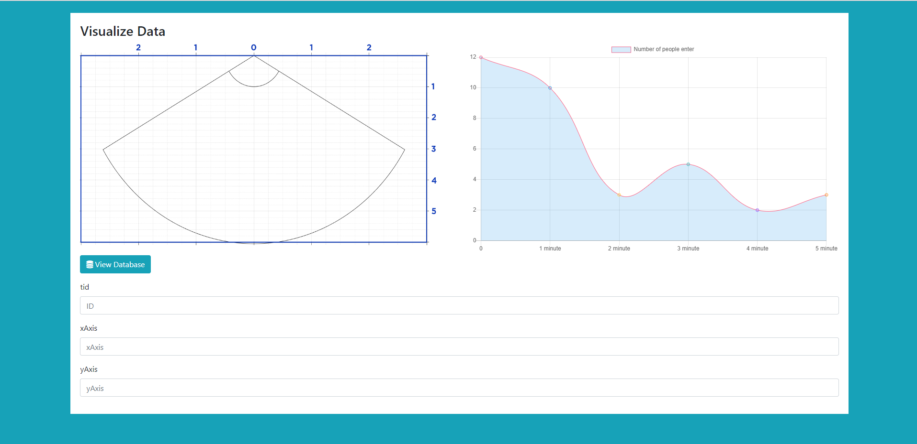

**Connect between Device and web server via Cloud MQTT, store the data in mongoDB**

CONNECT MQTT WITH NODE.JS

//------------------------CloudMQTT---------------------------------//

var mqtt = require('mqtt');

var Topic = '#';   // Sub to any topic

var err = Error

var options = {

    port: 11141,

    host: 'mqtt://soldier.cloudmqtt.com',

    clientId: 'mqttjs_' + Math.random().toString(16).substr(2, 8),

    username: 'spoeosqs',

    password: 'ac_554KtH4Gr',

    keepalive: 60,

    reconnectPeriod: 1000,

    clean: true,

    encoding: 'utf8'

};

var client = mqtt.connect('mqtt://soldier.cloudmqtt.com', options);

client.on('connect',mqtt_connect);

client.on('reconnect', mqtt_reconnect);

client.on('error', mqtt_error);

client.on('message', mqtt_messsageReceived);

client.on('close', mqtt_close);

function mqtt_connect()

{

    console.log("Connecting MQTT");

    client.subscribe(Topic, mqtt_subscribe);

}

function mqtt_subscribe(err,grant)

{

    console.log ("Subcribed to " + Topic);

    if (err) {console.log(err);}

}

function mqtt_reconnect(err)

{

    console.log("Reconnect MQTT");

    if (err) {console.log(err);}

    client  = mqtt.connect('mqtt://soldier.cloudmqtt.com', options);

}

function mqtt_error(err)

{

    console.log("Error!");

    if (err) {console.log(err);}

}

function mqtt_messsageReceived(topic, message, packet)

{

    console.log('Topic=' +  topic + '  Message=' + message);

}

function mqtt_close()

{

    console.log("Close MQTT");

}

//-----------------------------------------------------------------------/

**RESULT**

Message from CloudMQTT Broker

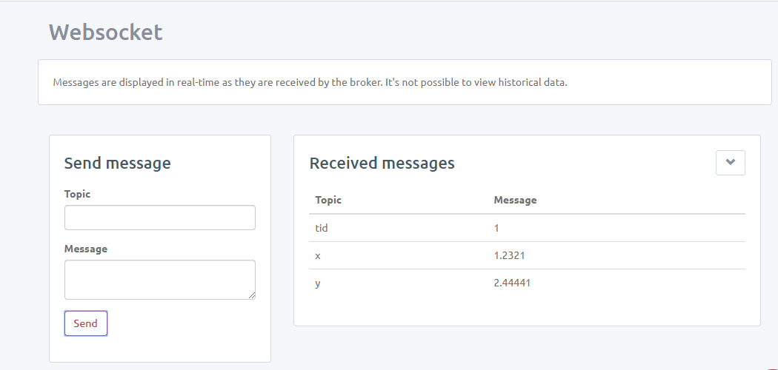

The app server received

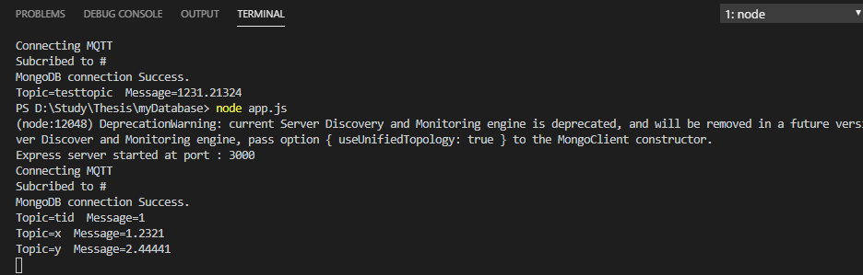

**INSERT DATA INTO MONGODB**

function mqtt_messsageReceiv(topic, message, packet)

{

    insertRecord(topic, message);

    console.log( topic + " " + message);

}

...

function insertRecord(a, b, c) {

    var location = new Location();

    location.tid = a;

    location.xAxis = b;

    location.yAxis = c;

    location.save((err, doc) => {

        if (!err)

           console.log("Good Job");// res.redirect('/location/list');

        else {

            console.log ('Error During recprd insert: ' + err);

        }

    });

}

Data received from CloudMQTT

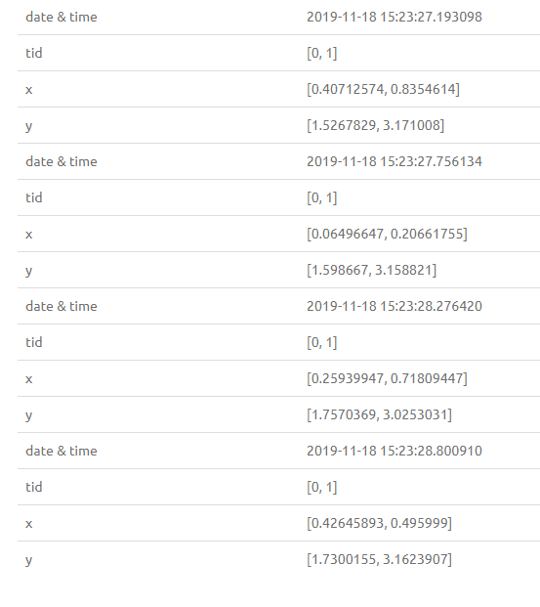

Receive on Terminal

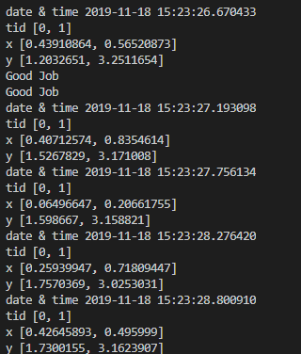

Store in MongoDB

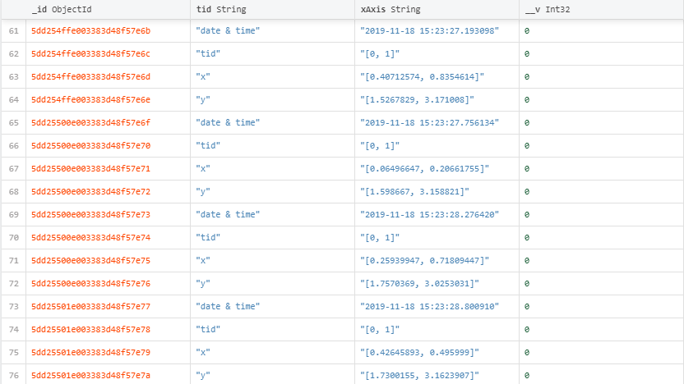

**Visualize the point**

            <script>

                var xfield = 6;

                var yfield = 6;

                var xpixel = 750;

                var ypixel = 425;

                var offset = 375;

                var tid = [1, 2, 3];

                var xPosition = [2, 1, 0];

                var yPosition = [3, 2, 5];

                var canvas = document.getElementById("targetCanvas");

                var ctx = canvas.getContext("2d");

                var image = new Image();

                function init() {

                    image.src = "../images/image1.jpg";

                    window.requestAnimationFrame(draw);

                }

                function drawBall(tag_xcale, tag_ycale) {

                    xLocation = (tag_xcale / xfield) * xpixel + offset;

                    yLocation = (tag_ycale / yfield) * ypixel;

                    ctx.beginPath();

                    ctx.arc(xLocation, yLocation, 10, 0, 2 * Math.PI);

                    ctx.fillStyle = "#2775f2";

                    ctx.fill();

                    ctx.closePath();

                }

                function draw() {

                    ctx.drawImage(image, 0, 0, canvas.width, canvas.height);

                    for (count = 0; count < tid.length; count++) {

                        drawBall(xPosition[count], yPosition[count]);

                    }

                    window.requestAnimationFrame(draw);

                };

                init();

            </script>

